**Northern Kenai Peninsula Area Treatment Plan**

**Treatment Plan: Tote Road Pike Lakes Restoration: Northern Pike Eradication**

**by**

**Rob Massengill and Kristine Dunker**

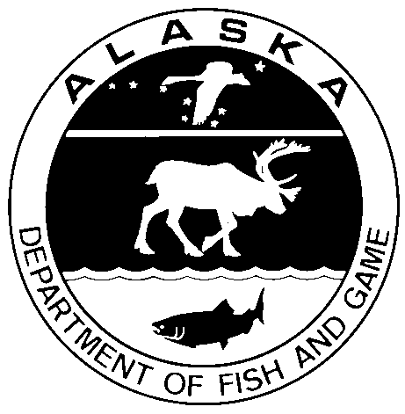

March 2017

Alaska Department of Fish and Game Divisions of Sport Fish and Commercial Fisheries

**Symbols and Abbreviations**

The following symbols and abbreviations, and others approved for the Système International d'Unités (SI), are used without definition in the following reports by the Divisions of Sport Fish and of Commercial Fisheries: Fishery Manuscripts, Fishery Data Series Reports, Fishery Management Reports, and Special Publications. All others, including deviations from definitions listed below, are noted in the text at first mention, as well as in the titles or footnotes of tables, and in figure or figure captions.

**Weights and measures (metric)**

centimeter cm

deciliter dL

gram g

hectare ha

kilogram kg

kilometer km

liter L

meter m

milliliter mL

millimeter mm

**Weights and measures (English)**

cubic feet per second ft3/s

foot ft

gallon gal

inch in

mile mi

nautical mile nmi

ounce oz

pound lb

quart qt

yard yd

**Time and temperature**

day d

degrees Celsius °C

degrees Fahrenheit °F

degrees kelvin K

hour h

minute min

second s

**Physics and chemistry**

all atomic symbols

alternating current AC

ampere A

calorie cal

direct current DC

hertz Hz

horsepower hp

hydrogen ion activity pH

(negative log of)

parts per million ppm

parts per thousand ppt,

‰

volts V

watts W

**General**

Alaska Administrative

Code AAC

all commonly accepted

abbreviations e.g., Mr., Mrs., AM, PM, etc.

all commonly accepted

professional titles e.g., Dr., Ph.D.,

R.N., etc.

at @

compass directions:

east E

north N

south S

west W

copyright ©

corporate suffixes:

Company Co.

Corporation Corp.

Incorporated Inc.

Limited Ltd.

District of Columbia D.C.

et alii (and others) et al.

et cetera (and so forth) etc.

exempli gratia

(for example) e.g.

Federal Information

Code FIC

id est (that is) i.e.

latitude or longitude lat or long

monetary symbols

(U.S.) $, ¢

months (tables and

figures): first three

letters Jan,...,Dec

registered trademark ®

trademark ™

United States

(adjective) U.S.

United States of

America (noun) USA

U.S.C. United States Code

U.S. state use two-letter abbreviations (e.g., AK, WA)

**Mathematics, statistics**

*all standard mathematical*

*signs, symbols and*

*abbreviations*

alternate hypothesis HA

base of natural logarithm *e*

catch per unit effort CPUE

coefficient of variation CV

common test statistics (F, t, χ2, etc.)

confidence interval CI

correlation coefficient

(multiple) R

correlation coefficient

(simple) r

covariance cov

degree (angular ) °

degrees of freedom df

expected value *E*

greater than >

greater than or equal to ≥

harvest per unit effort HPUE

less than <

less than or equal to ≤

logarithm (natural) ln

logarithm (base 10) log

logarithm (specify base) log2, etc.

minute (angular) '

not significant NS

null hypothesis HO

percent %

probability P

probability of a type I error

(rejection of the null

hypothesis when true) α

probability of a type II error

(acceptance of the null

hypothesis when false) β

second (angular) "

standard deviation SD

standard error SE

variance

population Var

sample var

***Regional Treatment plan SF.2A.2017.XX***

**Treatment Plan: Tote Road Pike Lakes Restoration: Northern Pike Eradication**

by

Robert Massengill

Alaska Department of Fish and Game, Division of Sport Fish, Anchorage

Alaska Department of Fish and Game  
Division of Sport Fish

March 2017

The Regional Operational Plan Series was established in 2012 to archive and provide public access to operational plans for fisheries projects of the Divisions of Commercial Fisheries and Sport Fish, as per joint-divisional Operational Planning Policy. Documents in this series are planning documents that may contain raw data, preliminary data analyses and results, and describe operational aspects of fisheries projects that may not actually be implemented. All documents in this series are subject to a technical review process and receive varying degrees of regional, divisional, and biometric approval, but do not generally receive editorial review. Results from the implementation of the operational plan described in this series may be subsequently finalized and published in a different department reporting series or in the formal literature. Please contact the author if you have any questions regarding the information provided in this plan. Regional Operational Plans are available on the Internet at: <http://www.adfg.alaska.gov/sf/publications/>

*Rob Massengill*

*Alaska Department of Fish and Game, Division of Sport Fish,*

*333 Raspberry Road,*

*Anchorage, AK*

*99518-1565*

*This document should be cited as follows:*

*Massengill, R. 2017. Tote Road Pike Lakes Restoration: Northern Pike Eradication. Alaska Department of Fish and Game, Regional Operational Plan ROP.SF.2A.2017.XX, Anchorage.*

The Alaska Department of Fish and Game (ADF&G) administers all programs and activities free from discrimination based on race, color, national origin, age, sex, religion, marital status, pregnancy, parenthood, or disability. The department administers all programs and activities in compliance with Title VI of the Civil Rights Act of 1964, Section 504 of the Rehabilitation Act of 1973, Title II of the Americans with Disabilities Act (ADA) of 1990, the Age Discrimination Act of 1975, and Title IX of the Education Amendments of 1972.

**If you believe you have been discriminated against in any program, activity, or facility please write:**

ADF&G ADA Coordinator, P.O. Box 115526, Juneau, AK 99811-5526

U.S. Fish and Wildlife Service, 4401 N. Fairfax Drive, MS 2042, Arlington, VA 22203

Office of Equal Opportunity, U.S. Department of the Interior, 1849 C Street NW MS 5230, Washington DC 20240

**The department’s ADA Coordinator can be reached via phone at the following numbers:**

(VOICE) 907-465-6077, (Statewide Telecommunication Device for the Deaf) 1-800-478-3648,

(Juneau TDD) 907-465-3646, or (FAX) 907-465-6078

**For information on alternative formats and questions on this publication, please contact:**

ADF&G, Division of Sport Fish, Research and Technical Services, 333 Raspberry Rd, Anchorage AK 99518 (907) 267-2375

Signature Page

|  |  |
| --- | --- |
| Project Title: | Tote Road Pike Lakes Restoration: Northern Pike Eradication |
| Project leader(s): | Robert Massengill, Kristine Dunker |
| Division, Region, and Area | Division of Sport Fish, Region II, Soldotna Office |
| Project Nomenclature: | Northern pike, Invasive species, Tote Road Pike Lakes, Gillnets, eDNA, Eradication, Rotenone |
| Period Covered | March 1, 2017 – October 30, 2019 |
| Field Dates: | July 1, 2017 – October 30, 2019 |
| Plan Type: | Treatment Plan |

**Approval**

|  |  |  |  |  |  |  |
| --- | --- | --- | --- | --- | --- | --- |
| Title |  | Name |  | Signature |  | Date |
| Project co- leader |  | Rob Massengill |  |  |  |  |
| Project co-leader |  | Kristine Dunker |  |  |  |  |
| Area research supervisor |  | Robert Begich |  |  |  |  |
| Biometrician |  | Adam Reimer |  |  |  |  |
| Research Coordinator |  | Tim McKinley |  |  |  |  |

TABLE OF CONTENTS

Page

LISt of tables iii

LIST OF FIGURES iii

LIST OF APPENDICES iii

INTRODUCTION 1

Background 1

Project Goal: 5

Project Objective: 5

Project Tasks: 5

project planning/authorizations 5

Guiding Management Plans 5

Clearances for Treatment 5

Methods 7

Waterbody Physical/Chemical Characterization 7

Bathymetric mapping 7

Water quality 7

Stream Discharge/Travel Time 8

Biological Inventory 8

*Invertebrates* 8

*Fish* 9

Pretreatment Northern Pike Removal 13

Fish Relocation/Restocking 14

Rotenone Treatment Overview 14

Bioassays 16

Calculating Amount of Product Needed for Lake Treatments 17

CFT Legumine™ Example 17

Treatment Details 17

Boat application 17

Backpack application 18

Rotenone Deactivation 19

Post Treatment 19

Fish Disposal 19

Treatment Success Evaluation 19

Water Monitoring 20

*Rotenone Sampling* 20

*Water Quality Sampling* 21

Data Collection 21

Biological Data 21

Water Quality and Stream Discharge Data 21

eDNA Sampling and Rotenone Monitoring Data 21

Data Reduction 22

Safety 22

Personnel duties 22

Reporting 23

LITERATURE CITED 24

# LISt of tables

Page

Table 1. Amount (in ml) of 50ppm rotenone stock solution (1 ml of CFT Legumine™ mixed in 1 liter of water) needed to achieve various concentrations of active rotenone in 20 liters of bioassay water. 16

# LIST OF FIGURES

Page

Figure 1. Map of Alaska’s northern pike native and invasive ranges. 2

Figure 2. Kenai Peninsula invasive northern pike waters status map. 3

Figure 3. Map of the Tote Road Pike Lakes and surrounding area. 4

Figure 4. Kenai Peninsula Borough map of general land ownership surrounding the TRPL area. The area encircled in red encompasses the general TRPL treatment area. 13

# LIST OF APPENDICES

Page

Appendix 1. Hope Lake bathymetric map 29

Appendix 2. Ranchero Lake bathymetric map 30

Appendix 3. Crystal Lake bathymetric map (also known as Leaf Lake or Big Dog Lake) 31

Appendix 4. Fred’s Lake bathymetric map 32

Appendix 5. Leisure Lake bathymetric map 33

Appendix 6. CC Lake bathymetric map (this map will be revised in 2017) 34

Appendix 7. Surface acres, maximum depth (m) and volume of lakes in the TRPL area. 35

Appendix 8. Hope Lake aquatic invertebrate sampling sites (W = Wisconsin net, D = D-Net and E = Ekman Dredge). 36

Appendix 9. Calculating the probability of detecting northern pike with gillnetting efforts. 37

Appendix 10. Summary of the hydrology in the TPRL. 40

Appendix 11. Project tasks, timelines and staffing requirements. 43

Appendix 12. CFT Legumine Fish Toxicant Specimen Label 45

Appendix 13. Safety Plans 51

Appendix 14. ADEC signage requirements for treatment site. 65

Appendix 15. ADEC pesticide recordkeeping requirements 67

Appendix 16. CFT Legumine™ Safety Data Sheet 68

# INTRODUCTION

## Background

=

In Alaska northern pike *Esox lucius* are an invasive species south and east of the Alaska Range (Figure 1) and are implicated in the decline of native fisheries throughout the region (Rutz 1999; Sepulveda et. al. 2013; Sepulveda et. al. 2015; Glick and Willette 2016; Patankar and Von Hippel 2006). There is evidence that northern pike prefer soft-finned juvenile salmonids over other available prey species in southcentral Alaska (Rutz, 1996 and 1999). Consumption of native juvenile salmonids by introduced northern pike has also been observed elsewhere in the northwestern United States (Rich 1992, McMahon and Bennett 1996, Schmetterling 2001, Muhlfeld et al. 2008). In Southcentral Alaska, northern pike prey may be particularly vulnerable to predation because they evolved in the absence of these predators whereas in interior Alaska, native northern pike share an evolutionary history with their prey which evolved adaptations for predator-avoidance (Oswood et al. 2000). Also, prevalent shallow lake morphology throughout much of southcentral Alaska offers limited deep water refugia for northern pike prey as northern pike prefer shallow vegetated waters (Cook and Bergersen. 1988, Inskip 1986).

Introduced northern pike were first documented on the Kenai Peninsula in the Soldotna Creek drainage in the 1970’s (ADFG unpublished). Subsequent dispersal and illegal introductions resulted in northern pike occurring in at least twenty-three Kenai Peninsula waterbodies (Figure 2). Of these, eleven such waterbodies were identified since 2000, however, the date of these introductions are unknown. Kenai Peninsula northern pike have reduced or eliminated wild and stocked fish populations from some lakes (McKinley 2013; Massengill 2014 a,b). Beginning in 2008, the Alaska Department of Fish and Game (ADFG) initiated a program to eradicate northern pike from the Kenai Peninsula. Initial efforts focused on eradicating northern pike from landlocked lakes (Massengill 2014a; 2014b) followed by eradication efforts in progressively more complex open waterbodies within the Swanson River and Soldotna Creek drainages. Currently, the Tote Road Pike Lakes (TRPL) harbors the last known northern pike population on the Kenai Peninsula.

Located about five miles south of Soldotna, the TRPL is currently comprised of eight small lakes of which seven are linked by intermittent stream flow. The linked lakes have an outlet creek (< 1cfs) that flows westward for about one mile then diffuses to a vast bog and eventually goes subterranean. and. In total, the waters of the TRPL cover about 92 surface acres and contain 1,200 of acre-feet of water. Five of the six lakes are found near Stubblefield Drive, two near Tote Road and one just north of Gruber Road (Figure 3). Threespine stickleback *Gasterosteus aculeatus* are believed to be the only fish species native to the TRPL although in most lakes they appear to be extirpated by northern pike predation. Rainbow trout *Oncorhynchus mykiss* were reported to occur in some lakes within the TRPL area decades ago but they likely resulted from undocumented introductions and did not represent a natural self-perpetuating population. Rainbow trout are no longer present in the TRPL area.

With the exception of threespine stickleback, the TRPL northern pike population does not pose a direct threat to local fisheries as the TRPL has no surface connections to waterbodies inhabited by fish other than threespine stickleback. However, northern pike in the TRPL do pose a very serious indirect threat to local fisheries in that this population is a convenient source for intentional introductions elsewhere. The closest anadromous waters to the TRPL is a tributary of Slikok Creek located about 0.6 miles southwest of Hope Lake.

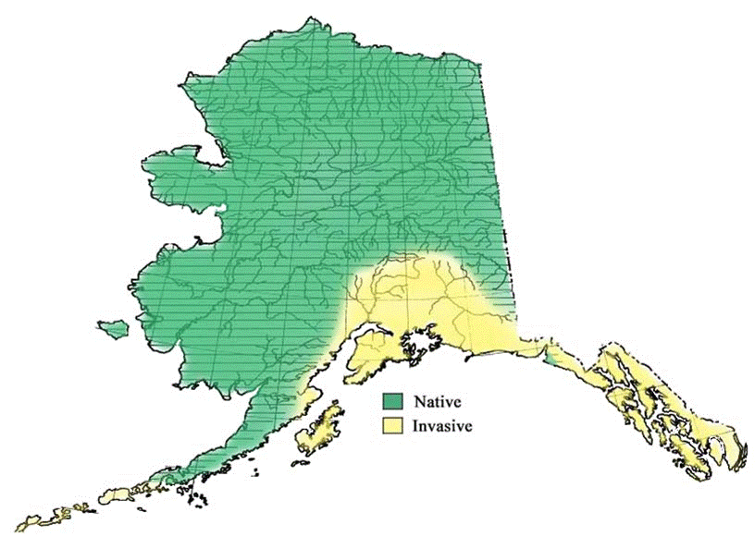

Figure 1. Map of Alaska’s northern pike native and invasive ranges.

Figure 2. Kenai Peninsula invasive northern pike waters status map.

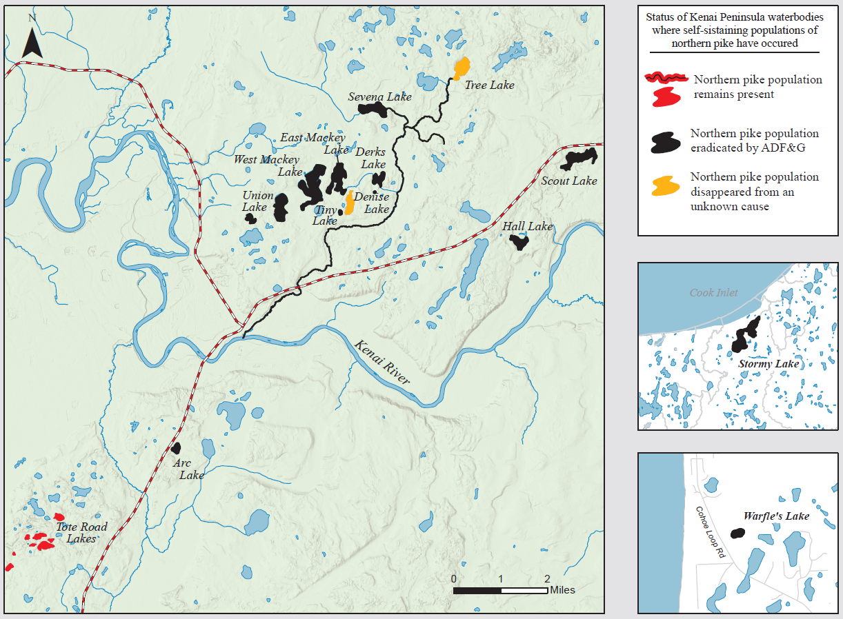

Figure 3. Map of the Tote Road Pike Lakes and surrounding area.

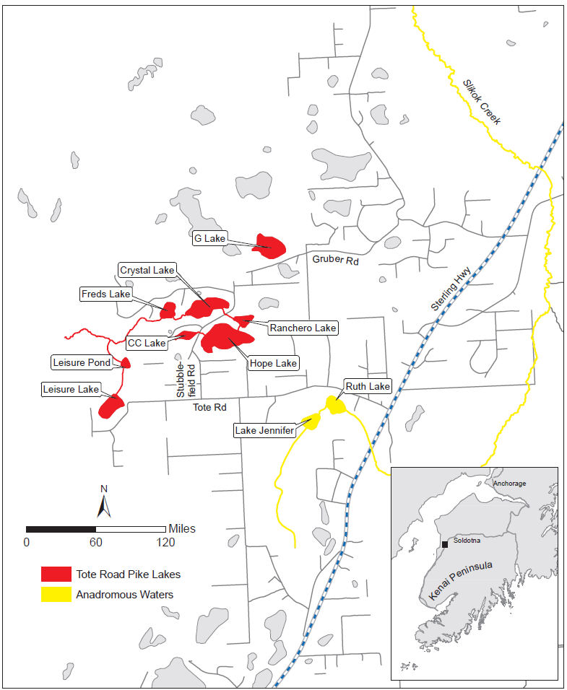

## Project Goal:

1) To restore the aquatic habitat of the TRPL

## Project Objective:

1. To eradicate the TRPL invasive northern pike population in 2018

## Project Tasks:

1. Conduct fish surveys in all waters within a 1.5 mile radius of Hope Lake in 2017
2. Conduct public scoping for eradicating northern pike from the TRPL

1. Fulfill all permitting obligations required to eradicate northern pike from the TRPL
2. Treat the TRPL with rotenone in the fall of 2018
3. Monitor the TRPL pre and posttreatment to include biological and water quality monitoring
4. Restock all the waters of the TRPL posttreatment with threespine stickleback beginning in 2019. Restock salmonids (rainbow trout and/or coho salmon) to those lakes with public access beginning in 2019

# project planning/authorizations

### Guiding Management Plans

The Department of Fish and Game Sport Fish Division has documents to guide the Department’s response to the threat of invasive northern pike. These documents include the Management Plan for Invasive Northern Pike available online at: <http://www.adfg.alaska.gov/static/species/nonnative/invasive/pike/pdfs/invasive_pike_management_plan.pdf>, and the Alaska Aquatic Nuisance Species Management Plan available online at: <http://www.adfg.alaska.gov/FedAidPDFs/RIR.5J.2002.10.pdf>. These plans aid in identifying specific threats from invasive northern pike, statutes and regulations pertinent to invasive species, and actions to evaluate, prevent, control, contain and eradicate invasive northern pike.

To prioritize northern pike control projects within the Region, a Department planning subcommittee developed a model that prioritized the numerous potential northern pike projects and defined program goals. Eradicating northern pike from the TRPL drainage is the highest ranking northern pike project priority remaining for the Northern Kenai Peninsula Management Area.

### Clearances for Treatment

The TRPL restoration project will require approvals by multiple government entities. The following is a list of the known permits and authorizations required for this project:

1. National Environmental Policy Act (NEPA) compliance: A federal nexus exists for the TRPL restoration project because the primary funding source for this project is the Alaska Sustainable Salmon Fund (AKSSF) which manages the State of Alaska allocation of the federal Pacific Coastal Salmon Recovery Fund (PCSRF) administered by National Oceanic and Atmospheric Administration Fisheries (NOAA). Having a federal nexus with a pesticide project mandates NEPA compliance, and in most cases, means that an environmental assessment (EA) be submitted to a reviewing federal agency. An EA for the TRPL drainage restoration proposal will be submitted to the USFWS Fishery Resource Office in Soldotna, Alaska. A public release of the TRPL restoration EA will be made available online by ADFG for public review. The USFWS will determine whether or not a “Finding of No Significant Impact” (FONSI) is applicable for the TRPL drainage restoration EA. If a FONSI is issued, that will conclude the Federal approval process for the EA. If a FONSI is not issued due to concerns that cannot be addressed by an EA revision, an environmental impact statement (EIS) may be required. To identify the existence of potential EPA pesticide use limitations for protection of endangered species within treatment area, and to help address those concerns in the EA if any exist, an EPA resource called the “Endangered Species Protection Bulletin” can be accessed online at: <http://www.epa.gov/oppfead1/endanger/bulletins.htm>. A USFWS listing of endangered species found in Alaska can be viewed online at: <http://ecos.fws.gov/ecp0/reports/species-listed-by-state-report?state=AK> .
2. Environmental Protection Agency (EPA) compliance: The National Pollutant Discharge Elimination System (NPDES) is an EPA program set out under section 402 of the Clean Water Act that requires pollutant discharges to surface waters be authorized by permit. EPA has transferred the permitting authority for Alaska discharges to the State of Alaska Department of Environmental Conservation (ADEC). The associated ADEC permit is called the Alaska Pollutant Discharge Elimination System (APDES). Details for this permit are available at: <http://dec.alaska.gov/water/wwdp/index.htm>
3. Alaska Department of Environmental Conservation (ADEC) Pesticide Use Permit (PUP): This permit is required for all Alaskan pesticide applications involving aircraft, applications to waters or executed by government agencies. The PUP requires the name(s) of the certified pesticide applicator(s) supervising the pesticide treatment in addition to extensive treatment plan details. ADEC also requires that the intended pesticide is registered for use in Alaska. Pesticide registration can be verified online at: <http://www.kellysolutions.com/ak/pesticideindex.htm>. To satisfy the ADEC Pesticide Use Permit Application requirements, two public notices must be placed in a local newspaper on two consecutive days per ADEC approval that describe the project and dates of the public commenting period for the permit. Often, the PUP notice is run concurrently with the EA notice in a local paper.
4. Kenai River Center Multi-Agency permit application. This permit is required for installing any structures (i.e., barriers, deactivation station) or for adding and removing fill in waterbodies. The multi-agency permit is reviewed by several agencies that include the Alaska Department of Natural Resources (Alaska State Parks), Alaska Department of Fish and Game (Habitat Division) and the Kenai Peninsula Borough.
5. Army Corps of Engineer permit: may be required for some fish barriers.
6. ADFG Board of Fisheries and ADFG Commissioner and Sport Fish Division Director consent.
7. Alaska Department of Fish and Game Fish Transport Permit (FTP) and Fish Resource Permit (FRP). An FTP is required to collect and transport wild juvenile salmonids for use as sentinel and bioassay specimens. An FRP is needed to capture and relocate fish for reintroduction following the pesticide treatment.
8. Alaska Department of Natural Resources (ADNR) Land Use Permit. This permit is required for activities on state lands, including submerged lands under navigable waterbodies, that are not considered a “generally allowed use” as defined in 11 AAC 96.020.

# Methods

### Waterbody Physical/Chemical Characterization

#### Bathymetric mapping

Bathymetric maps and volume estimates are needed for all the northern pike lakes within the TRPL area. Volume estimates and bathymetric maps allow estimation of the amount of pesticide (rotenone) needed for the project and for determining the rotenone application rate based on water depth. Current TRPL bathymetric maps are found in (Appendix 1-7) and volume estimates are found in Appendix 8. These maps and estimates were updated in the summer of 2017, prior to rotenone treatment. Bathymetric mapping for this project is conducted using technology that incorporates GPS instrumentation and GIS software.

Depth and location data (sonar logs) are gathered electronically and forwarded to a vendor for data processing. The data is collected using a boat mounted Lowrance™ HDS 7 Touch depth finder/chart plotter. The Lowrance™ HDS 7 Touch unit simultaneously records data at a user-selected "ping rate" (5 to 20 signals per second). Mapping coverage guidelines suggest that boat operators not exceed thirty feet between boat mapping swaths which can be visually monitored on the Lowrance™ HDS 7 Touch screen while mapping. Typically an entire lake is mapped by first mapping the lake perimeter then by mapping line transects across the lake. The Lowrance™ HDS 7 Touch mapping data can be stored on an SD card but no more than one hour of mapping data should be collected per SD card due to memory limits.

Once mapping is completed, all data records are uploaded to ciBioBase. ciBioBase is a subscription-based software service provided by Contour Innovations LLC and serves as a cloud-based GIS software platform that automates data processing of the Lowrance™ HDS sonar logs. At ciBioBase the data undergoes editing for erroneous data and interpolation using algorithms. Optional products include bathymetry maps, processed depth data records, volume estimates and vegetation reports.

#### Water quality

Water quality data will be collected from all TRPL waters on a monthly basis for one year before and one year following the rotenone treatment. This data will allow water quality comparisons and will be useful for assessing the appropriate target concentration of rotenone required and its potential persistence. Water quality can affect the effectiveness of rotenone which degrades faster in areas with higher light, heat, organics, shallows and turbidity, (Bradbury 1986; Dawson et al. 1991; and Schnick 1974). Rotenone is more effective when the water has low oxygen, pH, alkalinity and organic load (Wayne et. al. 2010). Low pH, alkalinity and temperature can increase rotenone persistence (Brian Finlayson, retired California Department of Fish and Game, personnel communication).

As suggested by Finlayson et al. (2000), water quality data useful for planning a rotenone treatment includes water temperature, pH, dissolved oxygen, specific conductivity, and turbidity. All those parameters except turbidity will be collected using a Quanta Hydrolab™. Turbidity will be measured with a Secchi disc to the nearest 0.1 meter. All water quality data will be collected from each lake in 1-meter increments beginning from just above the lake bottom at a location near the deepest part of each lake. Turbidity will be measured with a Secchi disc or similar device. Alkalinity will be measured at each lake just once before the rotenone treatment initiates using a Hach ™ Model AL-TA test kit. All water quality sampling locations will be recorded with a hand held GPS to facilitate sample site repeatability.

### Stream Discharge/Travel Time

Five of the lakes in the TRPL area are connected by intermittent streams. Fred’s Lake is the furthest downstream of the five linked lakes and its outlet stream flows westward about one mile where it diffuses into a vast fishless bog. Discharge in the steams connecting the TRPL waters are typically <.05 cfs based on sporadic historical discharge observations (ADF&G unpublished data). The stream connecting Ranchero Lake to Crystal/Leaf Lake travels under Stubblefield Drive through a semi-perched culvert and it is immediately downstream of this culvert where stream discharge can be measured by collecting the culvert’s discharge in a bucket to estimate gallons/second which is easily converted to cubic feet/second (cfs) (1 cfs = 7.48 gallons).

Typically, the stream discharge is too shallow for measurement with standard discharge measuring tools (i.e. wading rod and pygmy meter). Beginning in November, 2016 stream discharge will be measured monthly by bucket collection, as practical, for one year. If stream discharge appears sufficient for standard measuring methods, discharge will instead be measured with a Pygmy™ current meter attached to a wading rod and read with a battery powered AquaCount™ digital meter reader. Measuring techniques will comply with United States Geological Survey (USGS) specifications as described in Nolan and Shields (2000). The stream discharge measurement taken at the culvert under Stubblefield Drive will serve as a surrogate discharge measurement for all the streams linking the lakes within the TRPL. Stream discharge data will be recorded manually in the field in a Rite –in-the-Rain™ notebook and later transcribed to a Microsoft Excel database.

### Biological Inventory

#### *Invertebrates*

Rotenone is toxic to many aquatic invertebrates and some species are more tolerant than others. Whelan (2002) noted that the effects of rotenone on macroinvertebrates are most severe when treatments cover an entire watershed, the rotenone is at a high concentration, treatments are conducted multiple times in succession and are of long duration. Chulpach (1977) studied rotenone effects on zooplankton in southcentral Alaska lakes and noted that zooplankton populations crashed following the treatments but fully recovered in 1-3 years with no loss of species. Rotenone treatments conducted at Arc Lake (2008) and Scout Lake (2009) on the Kenai Peninsula indicate the diversity of posttreatment invertebrate taxa was similar to that pretreatment in less than one year, however, zooplankton abundance was temporarily but drastically reduced (Massengill 2014 a,b).

To document any large changes in aquatic invertebrate diversity in the TRPL area following the rotenone treatment, invertebrate sampling will be done at least twice during the summer of 2018 (pretreatment) and twice posttreatment in 2019. Invertebrate sampling will occur at one representative lake (Hope Lake). This sampling will provide a minimum list of taxa present in the TRPL area before and after the rotenone treatment. All sampling surveys will be conducted mid-summer when most aquatic invertebrates are in active life stages.

Zooplankton collections will be made at 2 sites by replicate vertical tows (from the bottom of the lake to the surface) in two mid-lake locations using a 0.5-meter diameter Wisconsin net with 153 µm mesh. The Wisconsin net will be lowered to near the lake bottom (~30 feet) with a hand line and then retrieved at a rate of 1 meter every 2 seconds. Captured zooplankton will concentrate in the net bottom inside a screened PVC collection bucket that is detachable from the net so captured zooplankton can easily be transferred to a collection jar. Zooplankton samples will be analyzed to a reasonable degree of taxonomic resolution using illustrations found in Bachmann (1973) and taxonomic keys found in Pennak (1989).

Multiple gear types will be used to sample macroinvertebrates. To collect benthic macroinvertebrates, a 9-inch Ekman Bottom Grab Sampler will be used to collect bottom sediment from four offshore sites. The Ekman dredge will be deployed from an anchored outboard boat at each of the four sites in 1 to 10m of water. Collected sediment will be screened through screening pans of varied mesh size to filter out invertebrates. Handheld D-nets will be used to sample invertebrates along five vegetated near-shore areas (<1.0m in depth) . The D-net will be swept the back and forth through submerged and emergent vegetation beds for 30 seconds. A visual wading/boating survey will conducted opportunistically to locate and collect freshwater mussels and/or snails. All macroinvertebrates collected will be identified to the taxonomic level of order or higher using keys provided by Pennack (1989) and Voshell (2002).

All sample site locations will be recorded with a GPS to ensure repeatability. A map showing approximate locations of all the lake invertebrate sampling sites is found in Appendix 8. All invertebrate specimens will be preserved in denatured ETOH, labeled with the date, gear method, collector initials and site location and archived at the Soldotna ADF&G Office.

#### *Fish*

Pretreatment minnow trapping surveys will be conducted in all lakes within the TRPL to confirm species presence. In each lake at least five minnow traps baited with salmon eggs will be fished for a minimum of one hour each. All catches will be speciated, enumerated and measured for fork length (FL) to the nearest mm. Fish sampling data including net/trap howill be recorded manually in the field in a Rite –in-the-Rain™ notebook and later transcribed to a Microsoft Excel database.

All lakes and ponds within a 1.5 mile radius of Hope Lake (approximately three dozen waterbodies) will be surveyed pretreatment for northern pike presence using both eDNA sampling methods and experimental gillnet surveys. The purpose of these surveys is to confirm the northern pike are still present in the six lakes comprising the TRPL area and that no previously undocumented northern pike populations are overlooked. The eDNA surveys will occur prior to the gillnet surveys to reduce the likelihood northern pike eDNA is accidentally introduced to waters by the gillnetting gear which could potentially cause false positive eDNA test results.

At each lake a minimum one sample for each 4.8 surface acres of lake or five samples, whichever is greater, will be collected during the mid-summer of 2017 and/or 2018. The seasonal timing of the collections is intentional in an effort to reduce the likelihood northern pike eDNA preserved in sediment from non-living sources (i.e. animal feces, failed introductions, etc.) becomes suspended in the water column from fall and spring turnover events. Previous northern pike eDNA sampling on the Kenai Peninsula during the springtime coincided with false positive eDNA detections which were hypothesized to have resulted from eDNA preserved in sediment getting resuspended in the water column (Dunker 2016). Also, eDNA sampling will not be conducted for one week following high wind events (> 20 mph) that could result in significant lake sediment disturbance.

eDNA sample sites will be subjectively chosen in each lake by the collectors who will target weedy littoral areas that appear to provide optimal pike habitat as described by Inskip (1984). This strategy of targeting optimal habitat with a sampling rate of one sample/4.8 surface acres produced an average positive northern pike eDNA detection rate of 82.4% during a recent Kenai Peninsula northern pike eDNA study (Dunker 2016).

Each eDNA sample will consist of a subsurface water grab collected in a sterilized one-liter Nalgene™ bottle. To minimize eDNA contamination risk, we will utilize DNA contamination prevention protocols similar to those described by Laramie et al. (2015) and Carime et al. (2015). Precautions will include sterilization of all sampling equipment using a 50% bleach solution rinse (50% deionized water: 50% household bleach product containing 8.25% sodium hypochlorite), followed by deionized water rinses between all sampling sites. New latex gloves will be donned for each sample collected. When possible, samples will be collected via foot travel along the lake bank. Chest waders will be worn that are sterilized with a bleach solution rinse prior to sampling each lake. If a boat is needed for sampling, staff will avoid driving the boat atop or beyond a sample site until the sample is collected. A bleach rinse solution will be used to sterilize the boat hull and it will air dried before launching at each lake. Immediately after collection, eDNA samples will stored in Whirl-Pak® bags then placed in a cooler with ice for transport.

To test for contamination during the sample collection and filtering, each day eDNA sampling occurs we will collect a travel, field, and lab blank. All blanks will consist of collecting a deionized water sample in a sterile 1-L bottle during specific phases of sample handling. First, a travel blank will be prepared prior to departing for the field and placed in the same container used to transport all samples throughout the day. Second, a deionized water sample will be collected in the field at each lake where sampling occurs using the same equipment used to collect the eDNA samples. Third, a lab blank will be prepared in the same room where the eDNA samples are temporarily stored then filtered.

An effort will be made to filter all eDNA samples within 24 hours of collection at the ADFG limnology lab in Soldotna. We will use a 120V Geotech™ peristaltic pump (Geotech Environmental Equipment, Inc.; Denver, CO) to draw water from the sample bottle through a silicon tube filter assembly that incorporates an inline round PVC filter holder. Filters will be round, 47-mm nitrocellulose mixed ester membrane (Sterlitech Corporation; Kent, WA). Filter pore size will be 1.0 μm. The number of filters required to filter each sample will vary depending on how much organic material is in the sample. All filters will be handled with sterilized metal tweezers. All filters from each unique water sample will be stored into a single sterile 50-ml centrifuge tube then sealed in a Whirl Pak® bag and placed into -20° C storage until processed.

Prior to filtering each eDNA sample, all tweezers and filter pump assemblies will be sterilized in a 50% bleach solution bath for 10-15 minutes followed by two deionized water baths. Before filtering a new sample, the pump and associated work area will be sprayed with a 10% bleach solution and wiped dry. The filter assembly will be reassembled and 0.5 - 1.0 L of deionized water pumped through the assembly as a final rinse. New latex gloves will be worn whenever a new sample is handled.

All eDNA samples will be processed by the U.S. Fish & Wildlife’s Conservation Genetics Laboratory (Anchorage, AK) using qPCR assay methods described in Olsen et.al. (2015) and Olsen et. al. (2016). A standard curve will be run for the qPCR assay to help estimate absolute quantity of DNA found in each sample.

Gillnetting surveys will be conducted to aid in assessing northern pike distribution. At each waterbody surveyed at least two to ten gillnets will be fished simultaneously to attain at least 48 hours of cumulative net soak time. The gillnets will be made of single-strand monofilament mesh with floating polypropylene hanging line and half-inch lead line and manufactured by Christiansen Net Company. Each net will be 120 ft. long, 6 ft. deep, with six -20 ft. wide panels of variable mesh net (1 each of sequentially attached half-inch, five-eighths-inch, three-quarter-inch, 1-inch, 1½-inch, and 2-inch stretched mesh). The nets will be fished in weedy littoral areas and generally parallel to the shoreline in waters 0.5 to 4.0 meters deep. Nets will be tethered to the shore at one end and a buoy placed on the untethered flagging end of the net to aid in retrieving the net. Owl decoys will be staked near any unattended net to discourage waterfowl from the area. Fish catches will be speciated, enumerated and measured for FL to the nearest mm. Fish of practical size for human consumption will be donated for food or utilized for educational uses. To reduce the potential for gillnets to transport invasive species, all gillnets upon removal will be visually inspected and cleaned of aquatic plant fragments then air dried and/or disinfected with a bleach solution soak and water rinse prior to redeployment in a new water body.

The probability of failing to detect a small population (20 individuals) of northern pike is provided in Appendix 9 (Table 2) under various levels of sampling effort. It is important to note that a positive eDNA detection does not necessarily mean live northern pike are present because non-living DNA sources or false-positives from DNA contamination could account for the detection. Therefore, any lake with a positive eDNA detection will be gillnetted with enough effort that the probability of failing to detect a population of 20 individuals is < 0.10 Only if a northern pike is physically captured will that waterbody will be included in the TRPL rotenone treatment area.

**Groundwater Hydrology/Risk Assessment**

A review of available well log data for the TRPL area was provided by the Alaska Department of Natural Resources (Appendix 10). This review summarizes surface and subsurface hydrology within the TRPL and assesses the risk of rotenone applied to surface waters to drinking water aquifers. Based on available well log data in the TRPL area, well depths are below a clay layer separating a lower aquifer utilized for well water from an uncontained upper aquifer that includes surface waters. The confining clay layer between the two aquifers will largely preclude uncontained surface waters and contaminants from reaching the lower aquifer.

ADF&G collected representative well water samples from six residences in the Soldotna Creek Drainage following rotenone treatments to the Mackey Lake system (2012) and Soldotna Creek (2016). Likewise, a housing complex water well near Loon Lake was sampled periodically for rotenone following a 2017 rotenone treatment of the lake. No rotenone or rotenolone (degradation product) was detected in any well. In addition, monitoring efforts of wells in conjunction with rotenone treatments in California, Oregon (Finlayson et al. 2001; Finlayson et al. 2014) or Montana (Don Skaar, MFWP, unpublished data) have not detected rotenone. Nonetheless, water samples from a private ground water well near each TRPL waterbody will be analyzed for rotenone periodically post-treatment to verify well water is not affected by the treatment.

**Public Scoping**

The Department will hold at least one or more public scoping meetings during 2017 and/or 2018 to provide stakeholders an opportunity to exchange information with the Department and comment about any issues or concerns they may have with this project. The meeting agenda will discuss the following: 1) background on invasive northern pike in Alaska, 2) why ADFG is concerned about the pike population in the TRPL area and 3) provide information on several Department action alternatives being considered (i.e. no action, long tern gillnetting, rotenone treatment (preferred alternative)). At a minimum, public scoping meetings will be advertised in an ADF&G news release and landowner notices delivered by hand or mail. Nearly all land surrounding the TRPL treatment area is in private ownership (Figure 4). In addition to a formal public scoping meeting, the project biologist will conduct door-to-door interviews with all available lakeside residents to provide landowners with project information and to solicit access for treatment related activities.

Periodic courtesy notices will be provided to TRPL landowners and other interested stakeholders to update then on project milestones. An environmental assessment (EA) and ADEC Pesticide Use Permit (PUP) is required for this project and both require public notices and 30-day commenting periods. Comments for the PUP will be directed to an ADEC representative and comments for the EA will be directed to the ADF&G project biologist. Comments directed to the EA will be summarized and addressed in a revision to the EA before submitting the EA to the USFWS for review and consideration of a Finding of No Significant Impact (FONSI).



Figure 4. Kenai Peninsula Borough map of general land ownership surrounding the TRPL area. The area encircled in red encompasses the general TRPL treatment area.

### Pretreatment Northern Pike Removal

In addition to pretreatment gillnetting surveys, gillnetting will occur in most of the TRPL waters prior to the rotenone treatment for the purposes salvaging northern pike to be donated to charity for food or sued for educational/research purposes.

### Fish Relocation/Restocking

If northern pike are not detected in the TRPL treatment area during posttreatment gillnetting surveys, all TRPL waters will be restocked with wild threespine sticklebacks collected from a wild southcentral Alaska population. This will restore the only known species of fish native to the TRPL. ADFG has received interest from several universities to utilize the stickleback restocking effort as a research opportunity for studying adaptive changes various forms of introduced stickleback populations (freshwater, anadromous, stream, pelagic, etc.) undergo after stocking in freshwater lakes. ADF&G has agreed to cooperatively restock the TRPL with an different forms of wild threespine stickleback pending approval of the required ADF&G permits. Similar stocking of anadromous threespine stickleback to establish new freshwater resident populations occurred at Scout Lake (Sterling, Alaska 2010) and Cheney Lake (Anchorage, Alaska 2009). The target number of threespine stickleback to be stocked into the TRPL has yet to be determined and ADF&G will coordinate with university staff to develop a stocking number goal.

To provide a replacement sport fishery to the TRPL northern pike sport fishery, ADF&G is planning to stock all TRPL waterbodies having some form of public access (i.e. right-of-way, section line easements, etc.) with either wild juvenile coho salmon and rainbow trout collected from the Kenai River drainage starting in 2019 or with hatchery-reared rainbow tourt. Annual target stocking densities will be determined later in the ADF&G Stateside Stocking Plan. Any wild fish used for restocking will be collected with minnow traps baited with salmon roe. Fish will be transported from the Kenai River drainage to the TRPL by highway vehicle equipped with an aerated live well.

Stocking of wild salmonids could occur annually for up to five years. If stocking of hatchery-reared fish is chosen to provide a fishery, annual restocking could go on indefinitely to those lakes having some form of public access. In addition, fish provided by the ADFG Salmon in the Classroom program may be used to aid in restocking the TRPL. It is unlikely any salmonids stocked into the TRPL will result in a self-sustaining population. It is assumed that the historical rainbow trout population reportedly found in the TRPL prior to the introduction of pike resulted from undocumented illegal introductions. Rainbow trout and salmon generally require streams with gravel substrate in riffle areas for spawning (Raleigh et. al. 1984) and this habitat is very is nearly nonexistent in the TRPL.

### Rotenone Treatment Overview

Eradicating invasive northern pike from the TRPL will be achieved by applying rotenone to the waterbodies with northern pike. Currently, the known northern pike waters in the TRPL consist of eight lakes and their tributaries. Ongoing fish distribution survey work within a 1.5 mile radius of Hope Lake may result in new northern pike populations being identified which will be would expand the TRPL rotenone treatment area.

Rotenone is a naturally occurring substance derived from the roots of tropical plants in the bean and pea family including jewel vine (*Derris* spp.) and lacepod (*Lonchocarpus* spp.) that are found in Australia, Oceania, southern Asia, and South America (Ling 2003). People have utilized rotenone for centuries to capture fish for food in areas where these plants are naturally found (Quigley 1956, Bearez 1998, Robertson and Smith-Vaniz 2008). It has been used in fisheries management in North America since the 1930s (Finlayson et al. 2000).

There are several commercial formulations of rotenone available as a piscicide including liquid and powdered formulations. CFT Legumine™ is a liquid product of 5% rotenone with additives that facilitate the emulsification and dispersion of rotenone in water. CFT Legumine™ was selected as the product for this project because of its relative safety to applicators, high dispersal properties, and lower content of petroleum hydrocarbon solvents. CFT Legumine™ was analyzed for ingredients by an independent contractor for the California Fish and Game Department in 2007 (Fisher 2007).

This analysis showed that the primary inert ingredients of CFT Legumine™ is diethylene glycol ethyl ether (a solvent known as DGEE) (61.1%), Fennedefo 99™ - a fatty acid ester mixture(17.1%), N-methyl pyrrolidone - a solvent (9.8%), in addition to some trace volatile organic compounds (VOCs). None of the compounds identified are considered persistent in the environment nor will they bioaccumulate. They are rapidly biodegraded, hydrolyzed and/or degraded by sunlight.

Rotenone acts by inhibiting oxygen transfer needed for cellular respiration. The biochemical process affected by rotenone takes place within the cell mitochondria and involves blocking electron transport by inhibiting NADH-ubiquinone reductase, resulting in the uncoupling of the metabolic pathway oxidative phosphorylation (Singer and Ramsay 1994, USEPA 2007). Fish die from tissue anoxia due to cardiac and neurological failure (Ling 2003). It is effective at low concentrations with fish because it is readily absorbed into the bloodstream through the thin cell layer of the gills. Typically, non-target organisms that do not have this rapid absorption route are not negatively affected at the concentrations necessary to kill fish (Finlayson 2000, Ling 2003, NPS 2006, USEPA 2007, MFW&P 2008).

The ideal timing of the TRPL would be just prior to ice up during October 2018 althugh public scoping input may change this. A late fall treatment would greatly slow the natural degradation of rotenone caused by sunlight and warm temperatures so there would be little chance northern pike could avoid exposure to the pesticide . Previous cold weather rotenone treatments in southcentral Alaska lakes resulted in the rotenone persisting for 3-8 months. This contrasts with 2016 and 2017 warm water rotenone treatments (mid-late June) at Sevena Lake (Soldotna Creek drainage) wherein the rotenone degraded fully within 11 days or less of each application. The TRL treatment timing is also subject to change if conditions of extreme high water, unfavorable weather conditions, or other factors are present that could compromise the project’s success, cause a large increase in project costs, or compromise safety.

Specific treatment components are divided into steps and described in this section. Some of these steps listed will likely evolve and undergo revisions as this project moves through the public scoping and permitting processes or if new information is garnered from upcoming field work. These steps are as follows:

1. Bioassays
2. Product calculations
3. Rotenone treatment application details
4. Posttreatment monitoring

Appendix 11 provides a detailed list of the expected staff and equipment required to complete a single treatment of the TRPL.

### Bioassays

Bioassays are an important tool for evaluating acute toxicity (Saila 1954). Bioassays using live fish are needed to determine the minimum effective dose (MED) of rotenone to use in the TRPL.

The bioassays will occur just prior to the to the rotenone treatment. The rotenone product (CFT Legumine™) will be tested using similar environmental conditions (sunlight, temperature and water chemistry) expected during the actual treatment

Because it is very difficult to collect northern pike small enough to be suitable bioassays utilizing aquaria, juvenile coho salmon collected from the Kenai River drainage will be used as a surrogate species to test for the MED. Coho salmon rotenone tolerance (24-h LC50 = 3.6 ppb rotenone) is similar to northern pike tolerance (24-h LC50 = 2.2 ppb rotenone) (Markings and Bills 1976). Bioassays will evaluate the fate of fish at predetermined concentrations of rotenone. For each target concentration, at least four coho salmon will be placed in a white plastic five gallon bucket filled with 20 liters of TRPL site water then dosed with enough rotenone to attain the target rotenone concentration. A control bioassay will not be dosed with any rotenone. All fish weights will be recorded prior to placement in the buckets. Each bioassay will avoid loading the buckets at a rate greater than 1 gram of fish per liter (Brian Finlayson of California Department of Fish and Game, personal communication).

The bioassays will be conducted for up to eight hours, if necessary, and a MED determined. The criterion for selection of an MED for the TRPL treatments is the rotenone concentration that kills all the fish wit in eight hours (Finlayson et al. 2010). Depending on the pH, turbidity, temperature, sunlight intensity, water depth, organic loads and other variables, a minimum rotenone concentration should be least twice the observed MED determined by the bioassays (Finlayson et. al. 2014). Eight hour bioassays will be conducted with the following rotenone concentrations: 6.25 ppb, 12.5ppb, 25.0ppb, 50.0 ppb, 100.0ppb and 200.0 ppb.

Table 1 provides a reference for how much CFT Legumine™ stock solution is needed to attain various bioassay rotenone concentrations (Finlayson et al. 2010).

Table 1. Amount (in ml) of 50ppm rotenone stock solution (1 ml of CFT Legumine™ mixed in 1 liter of water) needed to achieve various concentrations of active rotenone in 20 liters of bioassay water.

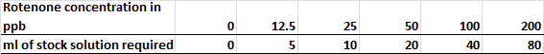

### Calculating Amount of Product Needed for Lake Treatments

The actual volume (gallons) of liquid CFT Legumine required to treat the TRPL will be determined by:

1. volume estimates for individual lakes,
2. consideration of treatment site/environmental conditions that could reduce the potency and mixing ability of the rotenone (i.e. organic load, weed beds, substrate type, etc.)
3. bioassay results to determine the MED

An example calculation is provided below that calculates the amount of liquid CFT Legumine™ required to treat a given volume of water at a specified rotenone concentration.

#### CFT Legumine™ Example

The CFT Legumine ™ specimen label (Appendix 12) indicates adding 1 gallon of CFT Legumine™ to 1 acre-foot of water will create a rotenone concentration of 0.15 ppm (or 150 ppb). Therefore, adding 0.00667 gallons of CFT Legumine™ (1/150) to one acre-foot of water produces a rotenone concentration of 1.0 ppb.

Therefore,

$$G_{p}=R_{c}×A_{e}×0.006667\frac{(gallons of CFT Legumine)}{acrefeet of water}$$

where,

$$G_{p}=CFT legumine required to acheive R_{c} (in gallons)$$

$$R_{c}=Rotenone concentration target or the waterbody (in ppb)$$

$A_{e}=Volume estimate for the waterbody (in acrefeet)$

So a waterbody estimated to contain 100 acre-feet and having a target rotenone concentration of 40 ppb would require 26.7 gallons of CFT Legumine™

$G_{p}=40ppb ×100 acrefeet×0.006667\frac{gallons}{acrefeet}$ = 26.7 gallons of CFT Legumine™

### Treatment Details

#### Boat application

TRPL waters will likely be treated with CFT Legumine™ in the fall of 2018 just prior to freeze up. The treatment will consist of applicators using outboard boats and backpack sprayers. Lakes will be partitioned into two or more treatment sections of similar size, with the water volume of each section estimated using GIS software and bathymetric (x,y and z) data (Appendix 1-8). The lake partition boundaries will be identified using tethered buoys. Treating the lakes in subsections helps ensure the rotenone is dispersed more evenly. Because all the lakes are relatively shallow (<32 feet), the CFT Legumine™ will mosly be applied to the lake surface although a weighted hose may help to apply rotenone to waters < 15 feet in depth. The specific gravity of CFT Legumine™ is 9% higher than water so the product will sink and help promote dispersion into deeper areas (Finlayson 2000).

In each lake section the application boat(s) will first apply the product along the perimeter then continue to make application swaths in increasingly smaller concentric circles towards the center of the section. Once a section is treated the boat applicators will continue on to an adjacent lake section and repeat the process until all sections are completed. Application swath width should not exceed 30 feet as suggested by Randall (2006). Boat speed will be manipulated during the application in an attempt to apply the CFT Legumine™ as evenly as possible with respect to the water depth being traversed. For instance, the application boat will slow over deeper water and speed up over shallower waters to help control the rate of application.

A GPS/chart plotter mounted on the boat console will allow boat applicators to visually track their application swaths, water depth, and boat speed to ensure no large gaps in coverage occur and boat speed is appropriately adjusted. A spreadsheet developed for calculating the preferred boat speed for a given water depth and pesticide pumping rate will be used to print boat speed reference charts that boat applicators can use for quick reference in the field. One chart will be for a slow pesticide pump rate (0.25 gallons of CFT Legumine™/minute) for waters < five feet in depth and the other for 1.0 gallons of CFT Legumine™/minute for water depths ≥ five feet. The total amount of rotenone applied to each section will be recorded by the project leader who will coordinate the entire rotenone application. Once an entire lake is treated, the application boat(s) will be driven randomly across the lake in a manner that creates large boat wakes to help mix the rotenone.

A practical method to calibrate or test the discharge rate of the CFT Legumine™ in the field is to record the time it takes to pump a known volume of CFT Legumine™. By adjusting valve on the pesticide intake siphon line, an applicator can attain a desired discharge rate through trial and error. Conducting such testing prior to treatment using lake water is recommended. Adding marks to indicate preferred valve position on the siphon line valve body will help boat applicators quickly make adjustments to the pesticide discharge rate for water depths < five feet or ≥ five feet.

The boat application pump apparatus will consist of a portable gas operated trash pump mounted on the floor of a boat that draws lake water from a transom mounted 2-inch diameter intake line and discharges the water back into the lake through a 1.5-inch diameter discharge line mounted near the bow of the boat. A split on the intake line will be used as the pesticide siphon line and will consist of a smaller diameter flexible hose in the range of ¾ - 3/8-inch in diameter. This pump system premixes the CFT Legumine™ with lake water before it is discharged back into the lake as required by the product label.

#### Backpack application

Backpack spray applicators will apply CFT Legumine™ to areas difficult to treat by the boat applicators such as shallow weedy shorelines or in the small streams linking the lakes. Backpack sprayers have a four gallon tank capacity which requires adding 1.3 cups of CFT Legumine™ to four gallons of water (Finlayson et. al. 2010). Dye may be added to the mixture (about one tablespoon/tank), if desired, to aid in visually identifying areas that have been sprayed to prevent under or over treatment.

### Rotenone Deactivation

The rotenone applied to the TRPL will be allowed to naturally degrade and no deactivation using potassium permanganate is planned. Based on recent ADF&G projects where rotenone was applied during freeze-up, complete deactivation by natural mechanisms may require 3-8 months.

## Post Treatment

### Fish Disposal

Dead fish could begin to surface within hours of a rotenone treatment (Bradbury 1986). ADFG will retrieve dead fish in the TRPL as practical to reduce potential odor and nuisance issues. Carcass collections will continue regularly in the TRPL until ice-up or until carcasses become too scarce to justify the effort. Unrecoverable dead fish should help stimulate plankton growth and aid in the recovery of zooplankton and aquatic insect populations (WDFW 2002).

### Treatment Success Evaluation

The success of the treatment will be evaluated by multiple methods. The first method will be observing the responses of caged sentinel fish during and immediately following the treatment. Caged fish will be placed at various locations and depths within TRPL waterbodies, including areas likely to have poor water mixing. If all sentinel fish die within one day of the treatment, likely the treatment was sufficient to kill the northern pike population. If sentinel fish survive in some area of a lake, re-treating that area immediately with enough rotenone to kill the sentinel fish is warranted.

Additional treatment success evaluation will be conducted using posttreatment gillnet surveys. Gillnet effort (total days of gillnet effort) will be determined by each lake’s surface acreage and the desired probability of not detecting a small northern pike population of just four individuals. Details on calculating the probability of not detecting a small surviving northern pike population using gillnets is found in Appendix 9. Because of the relatively small size of waterbodies found in the TRPL area, it is reasonable to strive for a < 1% probability of not detecting a small surviving pike population based upon on assumptions and calculations described in Appendix 9.

Gillnet surveys will be conducted under the ice to reduce incidental take of non-target animals and conflicts with water recreationists. Nets will be set shortly after the rotenone treatment and just as the lakes begin to freeze over. One caveat of long-term under ice netting is the nets will freeze into the ice and cannot be removed or thoroughly inspected until ice-out. A northern pike caught long before removal at ice-out may decompose and be lost and not detected. Dunker (2016) conducted a northern pike carcass retention trial and reported that it took 49 days before the first of twelve gillnet-entangled northern pike carcasses to decompose enough to drop out of a gillnet that was suspended under the ice at Derks Lake (Kenai Peninsula). The TRPL waters are expected to have similar under-ice environmental conditions as Derks Lakes which is located about ten miles away. Therefore when nets used for the TRPL treatment success evaluation and fished under the ice for approximately 6-7 months are pulled in the spring observed catches will represent just fish captured in the last 49 days.. Under such a scenario, the post treatment netting evaluation could be considered an extension of the rotenone treatment in that any surviving individuals will be captured and killed with high probability at some point prior to ice-out. The gillnets and placement strategies used for the TRPL treatment evaluation will be identical to that describe for the pretreatment northern pike distribution surveys.

In addition to gillnetting, a minimum of five minnow traps baited with salmon eggs will be fished continuously for 24 hours in each treated lake to assess if small/juvenile fish survived the treatment. The minnow trapping survey will occur shortly after the rotenone in the TRPL waterbodies naturally detoxifies which will likely occur no later than June, 2019.

### Water Monitoring

#### *Rotenone Sampling*

Water and sediment samples will be collected periodically from TRPL waters. Samples will be analyzed for rotenone and rotenolone content and used to assess rotenone persistence, mixing and degradation rate.

Rotenolone is the lone toxic degradation product of rotenone and is about 1/10th as toxic. At each lake, pretreatment control samples will be collected from the following locations: 1) 0.5 meter below the lake surface, 2) a ground water well source and 3) nearshore lake sediment sample. The pretreatment samples will be collected about one week prior to the start of the rotenone treatment. Posttreatment, water samples will be collected periodically from each lake at the following locations: 1) 0.5 below the lake’s surface near the center of the lake, 2) (within 2 meters of the lake’s greatest depth), 3) a ground water well source. All sample sites will be recorded with a handheld GPS to facilitate site repeatability for subsequent sampling events.

The frequency of posttreatment water sampling will be determined by the observed degradation rate of rotenone but will likely approximate a monthly or bimonthly sampling schedule. The first post-treatment water and sediment samples will be collected about 24 hours after the rotenone is applied to capture near peak concentrations. Sampling will continue until rotenone is no longer present (defined as < 2.0ppb), at each waterbody.

Deep lake water samples will be collected using a Kemmerer sampler and shallow lake water samples will be collected either by submerging a collection bottle by hand or with a Kemmerer sampler. Well water will be collected by hand by holding a collection bottle below a spigot after it has discharged cold water for at least one minute. Sediment samples will be collected using a clean metal trowel to extract sediment from nearshore areas in < .5 meters of water. The size of each water and sediment sample is unknown at this time and will be determined by the recommendation of the yet-to-be contracted lab that will analyze them. All samples will be collected in sterilized amber glass bottles, immediately chilled on ice and expressed shipped to a contracted laboratory within 24 hours of collection accompanied by chain-of-custody documentation.

#### *Water Quality Sampling*

Posttreatment water quality data will be collected from all TRPL waters on a monthly basis for a full year post treatment as described earlier.

# Data Collection

# Biological Data

All fish captured in gillnets and minnow traps will be counted and identified to species. The fork lengths (FL; tip of nose of fork of tail) of all captured fish will be measured and recorded to the nearest millimeter. For each sampling event we will also record the date, collector initials, waterbody name, waypoint (location) and set/pull times of the gear. All data will be recorded in the field in a Rite-in-the Rain™ notebook.

# Water Quality and Stream Discharge Data

All water quality (depth, pH, Specific conductivity, DO, turbidity and temperature), waypoint (location), waterbody name, date/time, general weather conditions and collectors initials will be recorded in a Rite-in-the Rain™ notebook. Stream discharge data will be recorded in the field on Rite-in-the-Rain paper forms.

# eDNA Sampling and Rotenone Monitoring Data

Sampling data collected during eDNA surveys and rotenone monitoring will be recorded on each sample bottle’s label and will include: date/time, waterbody name, waypoint (location), water temperature, collector initials, and unique sample identification (date -waterbody name -sample number)

# Data Reduction

Data recorded in the field in Rite-in-the-Rain notebooks/paper forms and labels of sample bottles will be entered into MicrosoftTM Excel data files at the Soldotna ADF&G office. All Excel files will be converted to .csv format and electronically stored in a manner that allows public access to the electronic data per NOAA funding requirements (i.e. Alaska Sustainable Salmon Fund).

# Safety

There are safety plans for multiple aspects of this project which are located in Appendix 13. Alaska Department of Environmental Conservation pesticide signage and storage requirements are found in Appendix 14 and 15 respectively. The Safety Data Sheet for CFT Legumine is found in Appendix 16.

# Personnel duties

**Project leader:** Rob Massengill (FBII) and Kristine Dunker (FBIII) will be co-project leaders and will oversee all aspects of the treatment to include: fulfilling permitting requirements, facilitating public scoping, developing the treatment plan, reporting, coordinating treatment logistics, project budgeting and staffing, providing staff training, ensuring all safety requirements are met and overseeing all treatment and monitoring related tasks. This position will work with the Area Sport Fish Manager to address any media requests. This position will also be the primary contact for reporting any incidents and will adhere to the incident chain-of-command found in Appendix 13. Project leaders must be currently certified as an aquatic pesticide applicator for the State of Alaska and have successfully completed a four and a half day training course on rotenone and antimycin use in fish management.

**Outboard boat applicators:** A minimum of four people will be divided into two boat crews to apply CFT Legumine™ from outboard boats. Each boat will include a boat driver and at least one person to operate the pumping system that mixes and applies the rotenone mixture. One person will be assigned as team leader for all the boat applicators. This person will be most familiar with the application equipment and procedures and can serve to train others in proper boat application operation, oversee boat crew safety, ensure quality control of the boat application treatments and be responsible for the setup of boat application equipment including calibration of the pesticide pumping apparatuses.

**Backpack applicators:** at least two backpack applicators will be needed for the TRPL rotenone treatment. One person will be assigned as team leader for the backpack applicators. This person will be familiar with the equipment and application procedures and can serve to train others in the backpack application details such as proper application techniques, backpack sprayer maintenance and cleaning.

**Sentinel fish monitoring and dead fish removal:** at least two people will collect dead and dying fish in the TRPL area. This team will also place and monitor caged sentinel fish during the treatment.

**Loading, equipment maintenance, cleanup:** one or two people will be onsite to help troubleshoot equipment issues, load rotenone on boats by hand or with a bobcat and may also assist with cleaning of empty rotenone containers.

**Communication/media contact:** at least sport fish manager will be assigned as a contact for media or public interaction during the treatment

# Reporting

This project will be reported in an ADF&G Special Publication following the completion of one year of post-treatment monitoring. A first draft of the report will be available in the winter of 2020.

# LITERATURE CITED

Alaska Department of Fish and Game. Unpublished. Northern Pike Esox lucius L. in the Soldotna Creek System. Archived in the Soldotna ADFG office.

Bachmann, R. W. 1973. Laboratory manual for limnology. Department of Zoology and Entomology, Iowa State University, Ames, Iowa

Bearez, P. 1998. First archaeological indication of fishing by poison in a sea environment by the Engoroy population at Salango (Manabi, Equador). Journal of Archaeological Science 25: 943-948.

Bradbury. A. 1986. Rotenone and trout stocking. Unpublished. Washington Department of Fish and Game, Fisheries management Division.

Carim, K. J., T. Padgett-Stewart, T. M. Wilcox, M.K. Young, K.S. McKelvey, and M.K. Schwartz. 2015. Protocol for collecting eDNA samples from streams. U.S.D.A. Forest Service, National Genomics Center for Wildlife and Fish Conservation. V2.3.

Chlupach, R. S. 1977. Population studies of game fish and evaluation of managed lakes in the upper Cook Inlet drainage. Alaska Department of Fish and Game. Federal Aid in Fish Restoration, Annual Performance Report, 1976-1977, Project F-9-9, 18 (G-III-D), Juneau.

Cook. M.F. and E.P. Bergersen. 1988. Movements, habitat selection, and activity periods of northern pike in Eleven Mile Reservoir, Colorado. Transactions of the American Fisheries Society 117: 495–502.

Dawson, V.K., W.H. Gingerich. R.A. Davis, P.A. Gilderhaus. 1991. Rotenone persistence in freshwater ponds: effects of temperature and sediment adsorption. North American Journal of Fisheries Management. 11, 2: 226-231.

Dunker K.J., Sepulveda A.J., Massengill R.L., Olsen J.B., Russ O.L., Wenburg J.K. and A. Antonovich. (2016). Potential of Environmental DNA to Evaluate Northern Pike (Esox lucius) Eradication Efforts: Experimental Test and Case Study. PLoS ONE 11(9):e0162277. doi:10.1371/journal.pone.0162277.

Finlayson, B.J., R.A. Schnick, R.L. Caiteux, L. DeMong, W.D. Horton, W. McClay, C.W. Thompson, and GJ. Tichacek. 2000. Rotenone use in fisheries management: administrative and technical guidelines manual. American Fisheries Society, Bethesda, Maryland.

Finlayson, B., J. Trumbo, and S. Siepmann. 2001. Chemical residues in surface 3415 and ground waters following rotenone application to California lakes and 3416 streams. Pages 37-53 in R. Cailteux, L. DeMong, F. Finlayson, W. Horton, 3417 W. McClay, R. Schnick, and C. Thompson, editors. Rotenone in fisheries: are 3418 rewards worth the risks? American Fisheries Society, Trends in Fisheries 3419 Science and Management I, Bethesda, Maryland

Finlayson, B., R. Schnick, D. Skaar, J. Anderson, L Demong. W. Horton and J. Steinkjer. 2010. Planning and standard operating procedures for the use of rotenone in fish management-rotenone SOP manual. American Fisheries Society, Bethesda, Maryland.

Finlayson, B.J., J.M. Eilers and H.A. Huchko. 2014. Fate and behavior of rotenone in Diamond Lake, Oregon, USA following invasive Tui chub eradication. Environmental Toxicology and Chemistry, Volume 33, No. 7, pp. 1650-1655.

Fisher, J. P. 2007. Screening level risk analysis of previously unidentified rotenone formulation constituents associated with treatment of Lake Davis. Report prepared for California Department of Fish and Game. ENVIRON International Corporation, Seattle, Washington.

Glick, W.J. and T.M. Willette. 2016. Relative abundance, food habits, age, and growth of northern pike in 5 Susitna River drainage lakes, 2009-2012. Alaska Department of Fish and Game, Fishery Data Series No. 16-34, Anchorage.

.

Hisata, J.S. 2002. Lake and stream rehabilitation: rotenone use and health risks. Final Supplemental Environmental Impact Statement. Washington Department of Fish and Wildlife.

Inskip, P.D. 1982. Habitat suitability index models: northern pike. United States Department of Interior, USFWS. FWS/OBS-82/10.17.

Laramie, M.B., Pilliod, D.S., Goldberg, C.S., and Strickler, K.M., 2015, Environmental DNA sampling protocol—Filtering water to capture DNA from aquatic organisms: U.S. Geological Survey Techniques and Methods, book 2, chap. A13, 15 p., <http://dx.doi.org/10.3133/tm2A13>.

Ling, N. 2003. Rotenone- a review of its toxicity and use for fisheries management. Science for Conservation 211, 40 p. ISBN 0-478-22345-5.

Markings, L. L. and T. D. Bills. 1976. Toxicity of Rotenone to Fish in Standardized Laboratory Tests. Investigations in fish control, Technical Report 72. U.S, Fish and Wildlife Service, National Fisheries Research Center, La Crosse, Wisconsin.

Massengill, R. L. (2014a). Control efforts for invasive northern pike on the Kenai Peninsula, 2008. Anchorage., Alaska Department of Fish and Game, Special Publication No. 14-12. Available at: <http://www.adfg.alaska.gov/FedAidPDFs/SP14-11.pdf>

Massengill, R. (2014b). Control efforts for invasive northern pike on the Kenai Peninsula, 2009. Anchorage., Alaska Department of Fish and Game, Special Publication No. 14-11. Available at: <http://www.adfg.alaska.gov/FedAidPDFs/SP14-11.pdf>

McKinley, T. R. (2013). Survey of northern pike in lakes of Soldotna Creek drainage, 2002. Anchorage., Alaska Department of Fish and Game, Special Publication No. 13-02. Available at: <http://www.adfg.alaska.gov/FedAidPDFs/SP13-02.pdf>

McMahon, T. E., and D. H. Bennett. 1996. Walleye and northern pike: boost or bane to northwest fisheries? Fisheries 21(8):6–13.

MFWP. 2008. (Montana Fish, Wildlife and Parks): Tunnel lake environmental assessment. Choteau, Montana. Available online at: <http://fwp.mt.gov/publicnotices/default.aspx>.

Mills, M. J. 1991. Harvest, catch, and participation in Alaska sport fisheries during 1990. Alaska Department of Fish and Game, Fishery Data Series No. 91-58, Anchorage. <http://www.sf.adfg.state.ak.us/FedAidPDFs/fds91-58.pdf>

Muhlfeld, C.C., D.H. Bennett, R. K. Steinhorst, B.M., Matthew Boyer. 2008. Using bioenergetics modeling to estimate consumption of native juvenile salmonids by nonnative northern pike in the Upper Flathead River system, Montana. North American Journal of Fisheries Management 2008 28:3, 636-648.

Nolan, K.M. and R.R. Shields. 2000. Measurement of stream discharge by wading. Water Resources Investigations Report 00-4036. United States Geological Survey.[http://training.usgs.gov/ntc/courses/cbt-cdrom/cbtindex.html](http://training.usgs.gov/ntc/courses/cbt-cdrom/cbtindex.html%20%20  )

NPS. 2006. Restoration of westslope cutthroat trout in the East Fork Specimen Creek watershed: Environmental Assessment. National Park Service, U.S. Department of Interior, Yellowstone National Park, Wyoming. Available online at: <http://www.nps.gov/yell/parkmgmt/uplad/wctrestoration_ea.pdf> )

Olsen JB, Lewis CJ, Massengill RL, Dunker KJ, Wenburg JK. Erratum to: An evaluation of target specificity and sensitivity of three qPCR assay for detecting environmental DNA from Northern Pike (Esox lucius). Conservation Genetics Resources. 2016:1-. doi: 10.1007/s12686-016-0526-y.

Olsen JB, Lewis CJ, Massengill RL, Dunker KJ, Wenburg JK. An evaluation of target specificity and sensitivity of three qPCR assays for detecting environmental DNA from Northern Pike (Esox lucius).Conservation Genetics Resources. 2015; 7:615–7.

Oswood, M.P., J.B. Reynolds, J.C. Iron and A.M. Miller. 2000. Distributions of freshwater fishes in ecoregions and hydroregions of Alaska. Journal of the North American Benthological Society, 19: 405-418.

Patankar, R., F. Von Hippel and M. Bell. 2006. Extinction of a weakly armored threespine stickleback (Gasterosteus aculeatus) population in Prator Lake, Alaska. Ecology of Freshwater Fish 15: 482–487.

Pennak, R. W. 1989. Third. Fresh-water invertebrates of the United States: Protozoa to Mollusca. Wiley and Sons, Inc., United States of America.

Plummer, M. 2013. R package version 3-11. rjags: Bayesian graphical models using MCMC. <http://CRAN.R-project.org/package=rjags>

R Core Team 2016. R: A language and environment for statistical computing. R Foundation for Statistical Computing, Vienna, Austria. URL https://www.R-project.org/.

Quigley, C. 1956. Aboriginal fish poisons and the diffusion problem. American Anthropologist, New Series 58: 508-525.

Raleigh, R. F., T. Hickman, R. C. Solomon, and P. C. Nelson. 1984. Habitat suitability information: Rainbow trout. U.S. Fish Wildlife. Service. FWS/OBS-82/10.60. 64 pp. <https://archive.usgs.gov/archive/sites/www.nwrc.usgs.gov/wdb/pub/hsi/hsi-060.pdf>

Randall, C. and J. Stachecki, 2006. Aquatic Pest management, Category 5: A training manual for commercial pesticide applicators. Michigan State University, Extension Bulletin E-2437.

Rich, B. A. 1992. Population dynamics, food habits, movement, and habitat use of northern pike in the Coeur d’Alene system, Idaho. Master’s thesis. University of Idaho, Moscow.

Robertson, Ross D. and W.F. Smith-Vaniz. 2008. Rotenone: An essential but demonized tool for assessing marine fish diversity. Bioscience 58: 165-169.

Rutz, D. S. 1996. Seasonal movements, age and size statistics, and food habits of upper Cook Inlet northern pike during 1994 and 1995. Alaska Department of Fish and Game, Fishery Data Series No. 96-29, Anchorage. <http://www.sf.adfg.state.ak.us/FedAidPDFs/fds96-29.pdf>

Rutz, D. S. 1999. Movements, food availability and stomach contents of northern pike in selected Susitna River drainages, 1996-1997. Alaska Department of Fish and Game, Fishery Data Series No. 99-5, Anchorage. <http://www.sf.adfg.state.ak.us/FedAidPDFs/fds99-05.pdf>

Saila, S.B. 1954. Bio-assay procedures for the evaluation of fish toxicants with particular reference to rotenone. Transactions of the American Fisheries Society, Volume 83, Issue 1.

Schnick, R.A. 1974. A review on the literature on the use of rotenone in fisheries. Fish Control Laboratory, Lacrosse, Wisconsin.

Seber, G. A. F. 1982. The estimation of Animal Abundance and related parameters. The Blackburn Press, Caldwell, NJ.

Sepulveda, A. J., D. S. Rutz, A. W. Dupuis, P. A. Shields, and K. J. Dunker. 2015. Introduced northern pike consumption of salmonids in Southcentral Alaska. Ecology of Freshwater Fish 24:519-531.

Sepulveda, A. J., D. S. Rutz, S. S. Ivey, K. J. Dunker, and J. A. Gross. 2013. Introduced northern pike predation on salmonids in Southcentral Alaska. Ecology of Freshwater Fish 22:268-279.

Singer, T. P., and R. R. Ramsay. 1994. The reaction site of rotenone and ubiquinone with mitochondrial NADH dehydrogenase. Biochimica et Biophysica Acta 1187:198-202.

USEPA (United States Environmental Protection Agency). 2007. Reregistration eligibility decision for rotenone. Document EPA 738-R-07-007(March 2007). United States Environmental Protection Agency, Washington, D.C.

Vinson, M.R., E.C Dinger and D.K. Vinson. 2010 Piscicides and Invertebrates: After 70 years, Does Anyone Really Know? Fisheries, Volume 35:2, pages 61-71.

Voshell, R. J. 2002. A guide to common freshwater invertebrates of North America. McDonald & Woodward Publishing, Blacksburg, VA.

Wayne, F. and M. P. Masser. 2010. Removing Fish from Ponds with Rotenone. Southern Regional Aquaculture Center. Publication number 4101. Available at: <https://srac.tamu.edu/viewFactSheets>

WDFW. 2002. Lake and stream rehabilitation: rotenone use and health risks. Final supplemental environmental Impact Statement. Washington Department of Fish and Wildlife, Olympia, Washington.

Whelan, J. E. 2002. Aquatic macroinvertebrate monitoring results of the 1995 and 1996 rotenone treatments of Manning Creek, Utah. Utah Division of Wildlife Resources, Publication 02-04, Salt Lake City.

Appendix 1. Hope Lake bathymetric map

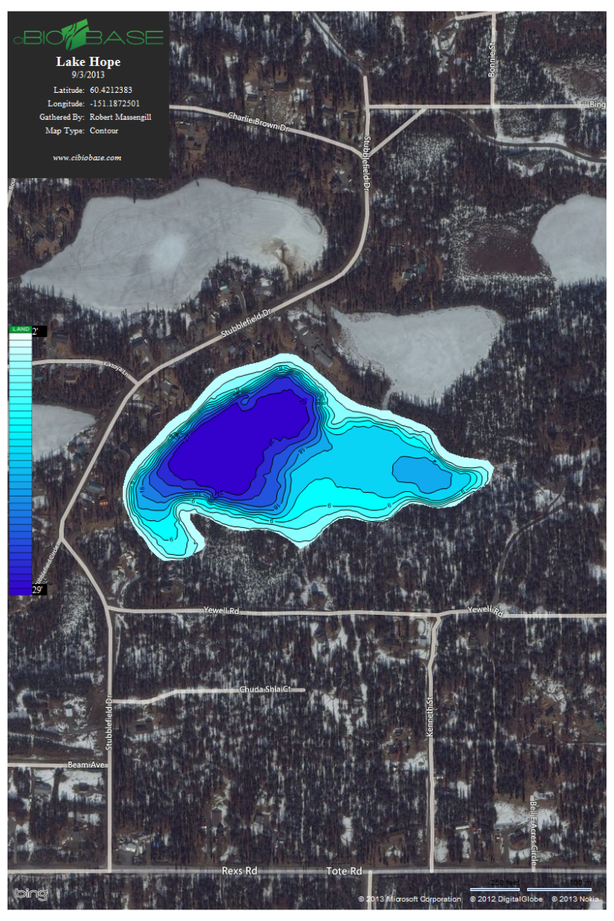

Appendix 2. Ranchero Lake bathymetric map

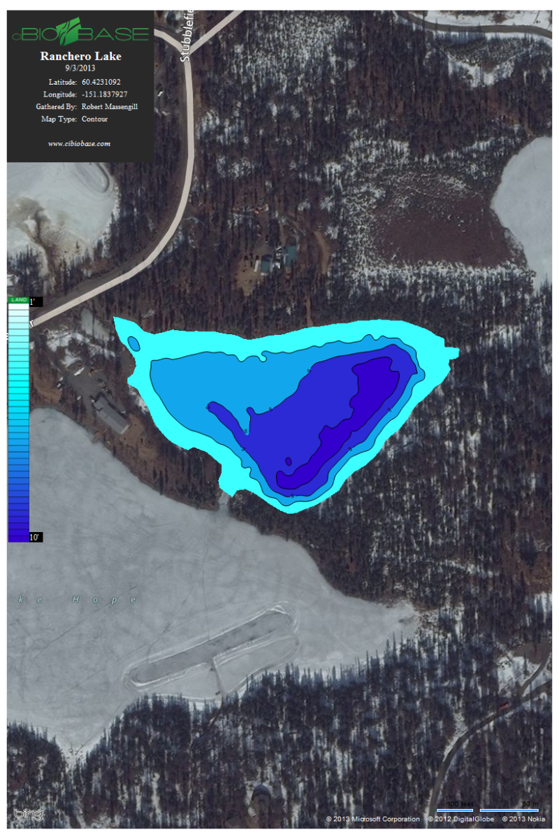

Appendix 3. Crystal Lake bathymetric map (also known as Leaf Lake or Big Dog Lake)

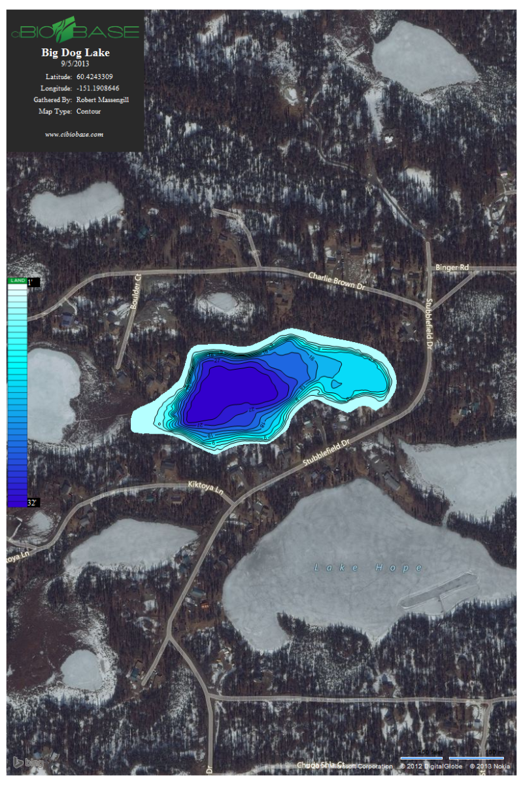

Appendix 4. Fred’s Lake bathymetric map

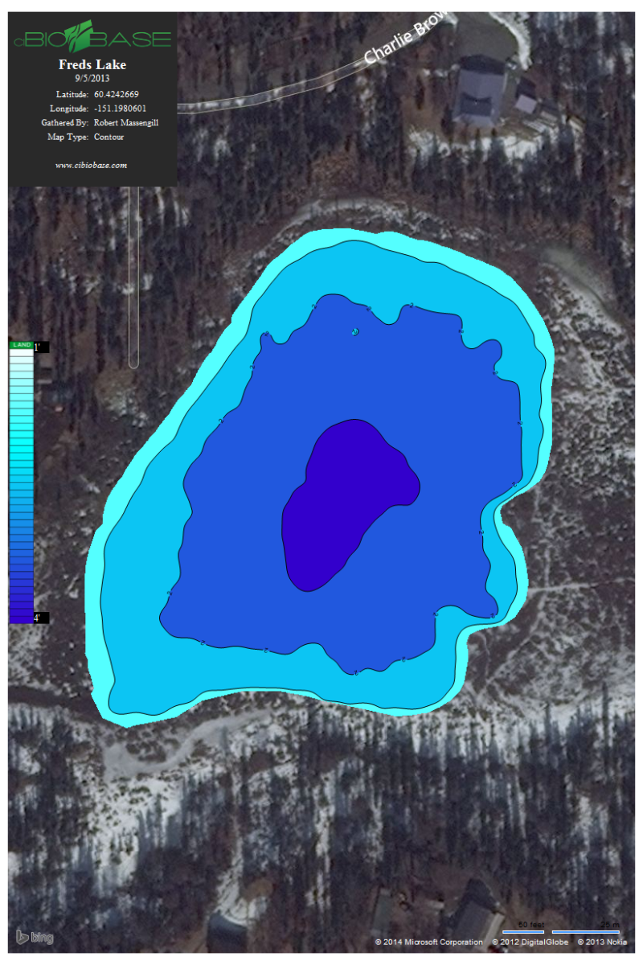

Appendix 5. Leisure Lake bathymetric map

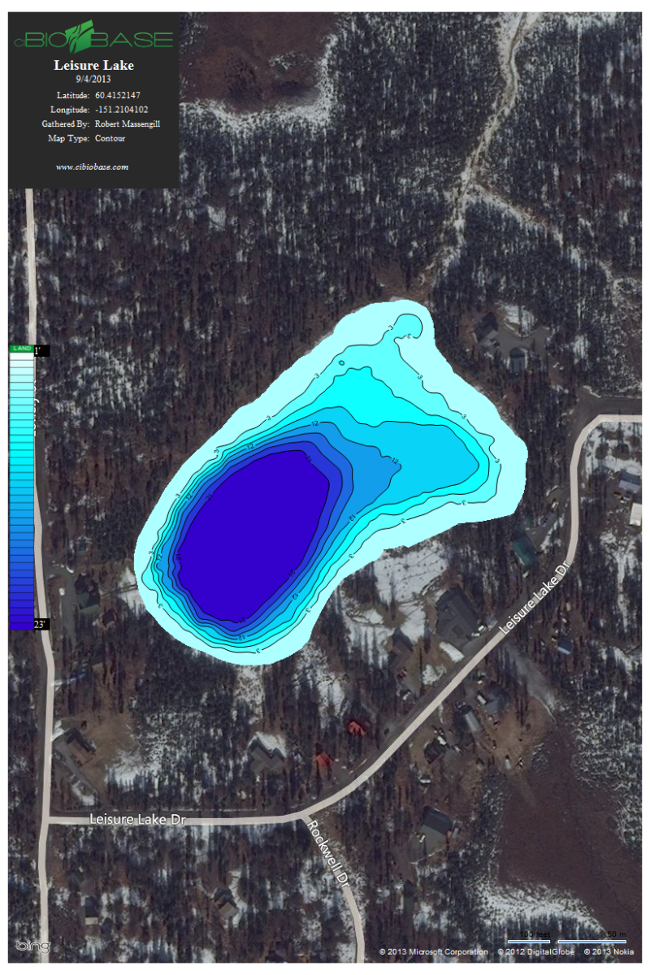

Appendix 6. CC Lake bathymetric map

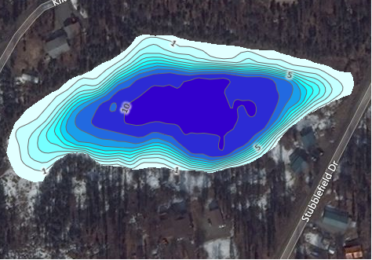

Appendix 7. G Lake bathymetric map

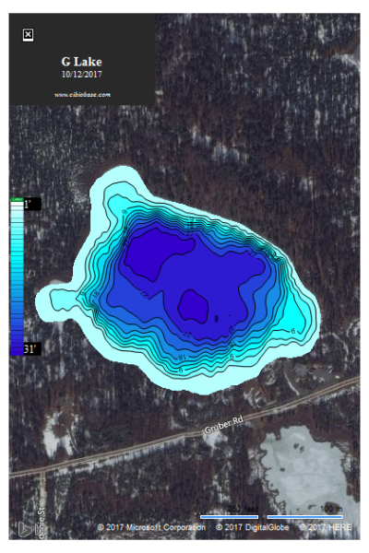

Appendix 8. Surface acres, maximum depth (m) and volume of lakes in the TRPL area.



Appendix 9. Hope Lake aquatic invertebrate sampling sites (W = Wisconsin net, D = D-Net and E = Ekman Dredge).



Appendix 10. Calculating the probability of detecting northern pike with gillnetting efforts.

Between 2005 and 2010, ADF&G conducted 12 removal experiments with northern pike populations on the Kenai Peninsula using similar sampling methods. Data collected from these experiments included catch $C_{ij}$ and effort $E_{ij}$ (in units of net-hours per surface acre) for sample $i (i=1, …, s)$ and experiment $j \left(j=1, …, 12\right).$ Populations are assumed to be closed except for fish caught and the fishing is assumed to represent a Poisson process with a constant probability of capture for all individuals. Data was analyzed using a hierarchical version of Leslie’s regression method (Seber 1982):

$${CPUE}_{ij} = K_{j}N_{j} - K_{j}C_{ij}^{*}$$

where:

$${CPUE}_{ij}= {C_{ij}}/{E_{ij}}$$

$$C_{ij}^{*} = \sum_{k=1}^{i-1}{C_{kj}} for \left(i in 2, …, s+1\right) with C_{1j}^{*}=0$$

$N_{j}$ = the initial population size in experiment j

$K_{j}$ = average probability that a fish is captured with one unit of effort during experiment j,

The probabilities of capture for each experiment are assumed to come from a common distribution:

$$K_{j} \sim beta\left(a, b\right)$$

The analysis was conducted using the RJAGS package (Plumber 2013) within R (R Core Team 2016). Non-informative priors were used for all parameters. Although Leslie’s method is typically used to estimate the initial population size our interest was in the posterior and predictive distributions of $K$ for the purpose of estimating the probability of detecting small pike populations in future removal experiments.

Percentiles from the predictive distribution for the value of *K* in a new removal experiment are shown in Table 1 and the predictive distribution is shown in Figure 1.

Table 1: Percentiles from the predictive distribution of *K*.

|  |  |
| --- | --- |
| Percentile | predicted *K* |
| 5% | 0.001 |
| 10% | 0.003 |
| median | 0.019 |
| 90% | 0.055 |
| 95% | 0.073 |

Appendix 9. page 2 of 3

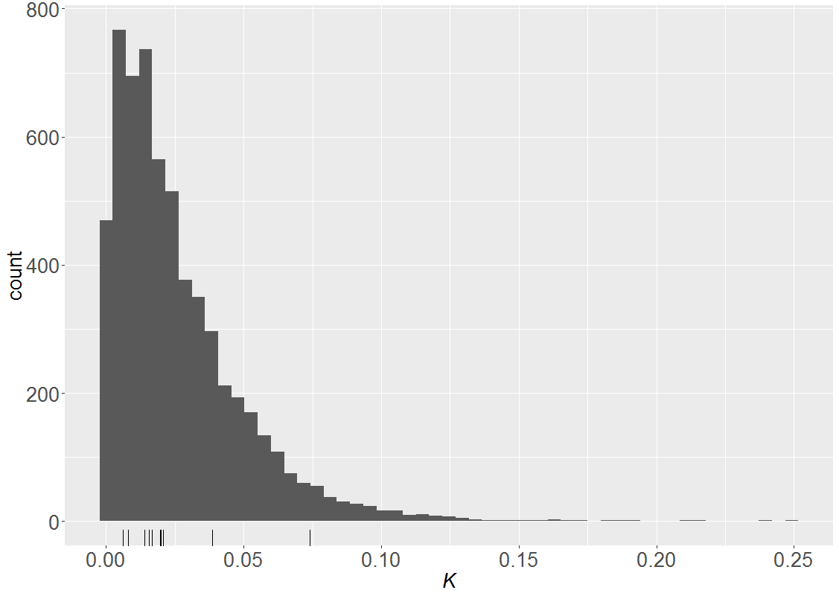

Figure 1: Prediction distribution for *K, the average probability a fish is captured in a new removal experiment with one unit of effort. Tick marks along the x-axis show the median values for Kj, the average probability a fish is captured with one unit of effort in each of the previous removal experiments.*

The probability of failing to detect a population of pike of size N using gillnetting is given by:

$$D_{p} ={exp⁡(-KE)}^{N}$$

Likely values of *K* can be chosen from the percentiles in Table 1, values of effort (E) are based on logistical considerations and values of N are based on the population size we are attempting to detect.

Detection probability is of interest in two situations. Pretreatment, lakes in close proximity to known pike lakes will be netted and sampled for eDNA to determine if additional lakes require rotenone treatment. In this situation we assume the median value of the prediction for *K* as netting will be conducted in open waters using similar methods as used during previous removal experiments. Our interest is in detecting a pike population of 20 individuals as populations as small as 25 individuals have been previously located in other Kenai Peninsula lakes (R. Massengill, personal communication). The probability of failing to detect a pike population of 20 individuals using various levels of netting effort is given in Table 2. In practice, each lake will also be sampled for pike eDNA. When at least one eDNA sample is collected for every 4.8 surface acres, the estimated probability of detecting pike eDNA in each sample was

Appendix 9. page 3 of 3

Table 2: Probability of failing to detect a population of 20 pike with various levels of netting effort.

|  |  |  |  |  |  |
| --- | --- | --- | --- | --- | --- |
|  | Net Density (nets per surface acre) | | | | |
| Hours fished | 0.1 | 0.25 | 0.5 | 1 | 2 |
| 6 | 0.793 | 0.629 | 0.313 | 0.098 | 0.010 |
| 24 | 0.395 | 0.156 | 0.010 | 0.000 | 0.000 |

demonstrated to be 0.824(Dunker et. al. 2016). The probability of both methods failing to detect a pike population, assuming one eDNA sample[1] and independence of the two techniques is shown in Table 3.

Table 3: Probability of failing to detect a population of 20 pike with various levels of netting effort and eDNA sampling (minimum of one sample/4.8 surface acres).

|  |  |  |  |  |  |
| --- | --- | --- | --- | --- | --- |
|  | Net Density (nets per surface acre) | | | | |
| Hours fished | 0.1 | 0.25 | 0.5 | 1 | 2 |
| 6 | 0.140 | 0.111 | 0.055 | 0.017 | 0.002 |
| 24 | 0.070 | 0.027 | 0.002 | 0.000 | 0.000 |

Post-treatment, rotenone treated lakes will monitored with gillnets placed under the ice to validate treatment success. In this situation, the 10th percentile of the predictive distribution for *K* is used because netting will occur under the ice and capture probabilities may be reduced from those experience during open water. Our interest is in detecting a population of only 4 pike. The probability of failing to detect a pike population of 4 individuals with various levels of netting effort is given in Table 4. Post-treatment sampling for eDNA will also occur although detection probabilities for eDNA are unknown with extremely small populations.

Table 4: Probability of failing to detect a population of 4 pike with various levels of netting effort.

|  |  |  |
| --- | --- | --- |
|  | Net Density (nets per surface acre) | |
| Months fished | 0.2 | 0.5 |
| 1 | 0.159 | 0.010 |
| 2 | 0.025 | 0.000 |
| 3 | 0.004 | 0.000 |
| 4 | 0.001 | 0.000 |
| 5 | 0.000 | 0.000 |
| 6 | 0.000 | 0.000 |

Appendix 11. Summary of the hydrology in the TPRL.

Page 1 of 2.

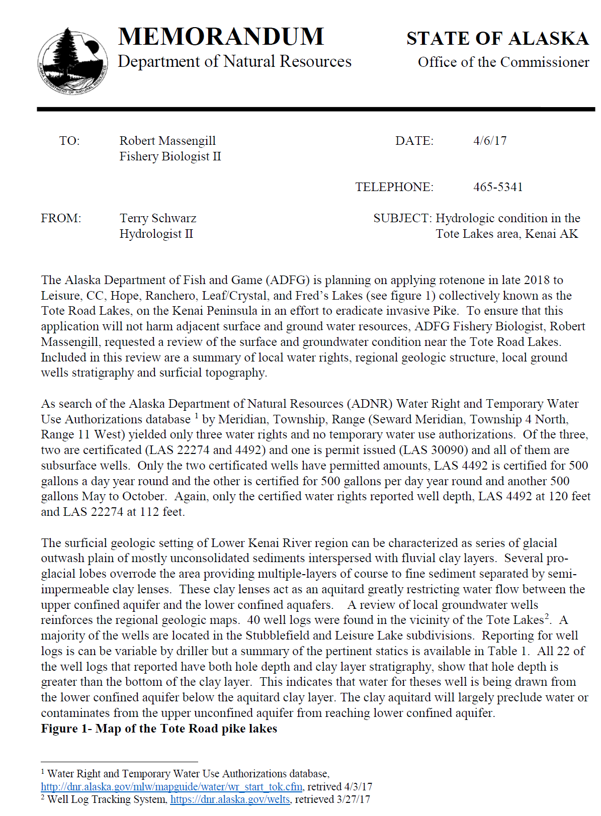

Appendix 10. Page 2 of 3.

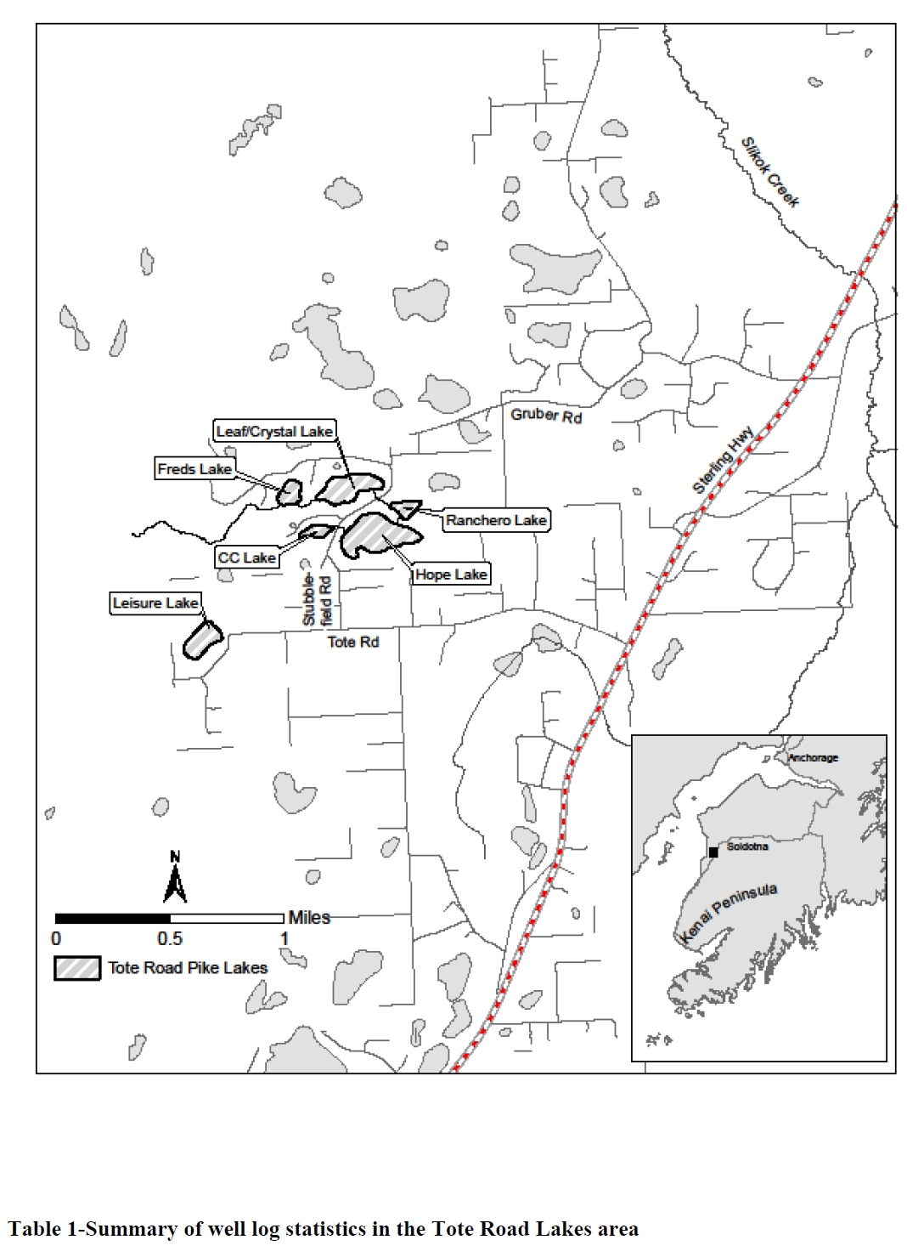

Appendix 10. Page 3 of 3.

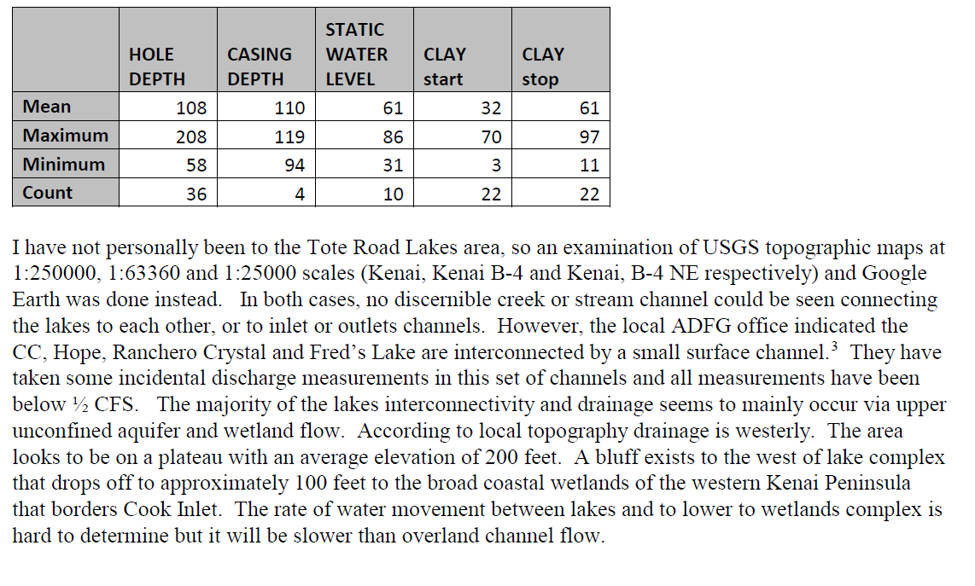

Appendix 12. Project tasks, timelines and staffing requirements.

Page 2 of 3



Appendix 11 continued

Page 2 of 2



Appendix 13. CFT Legumine Fish Toxicant Specimen Label

Page 1 of 6

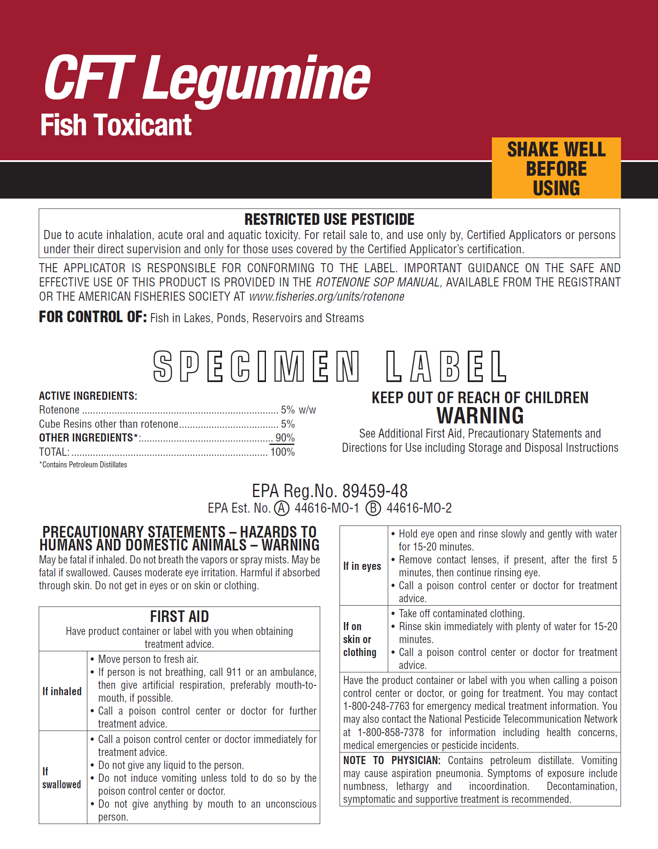

Appendix 12 page 2 of 6

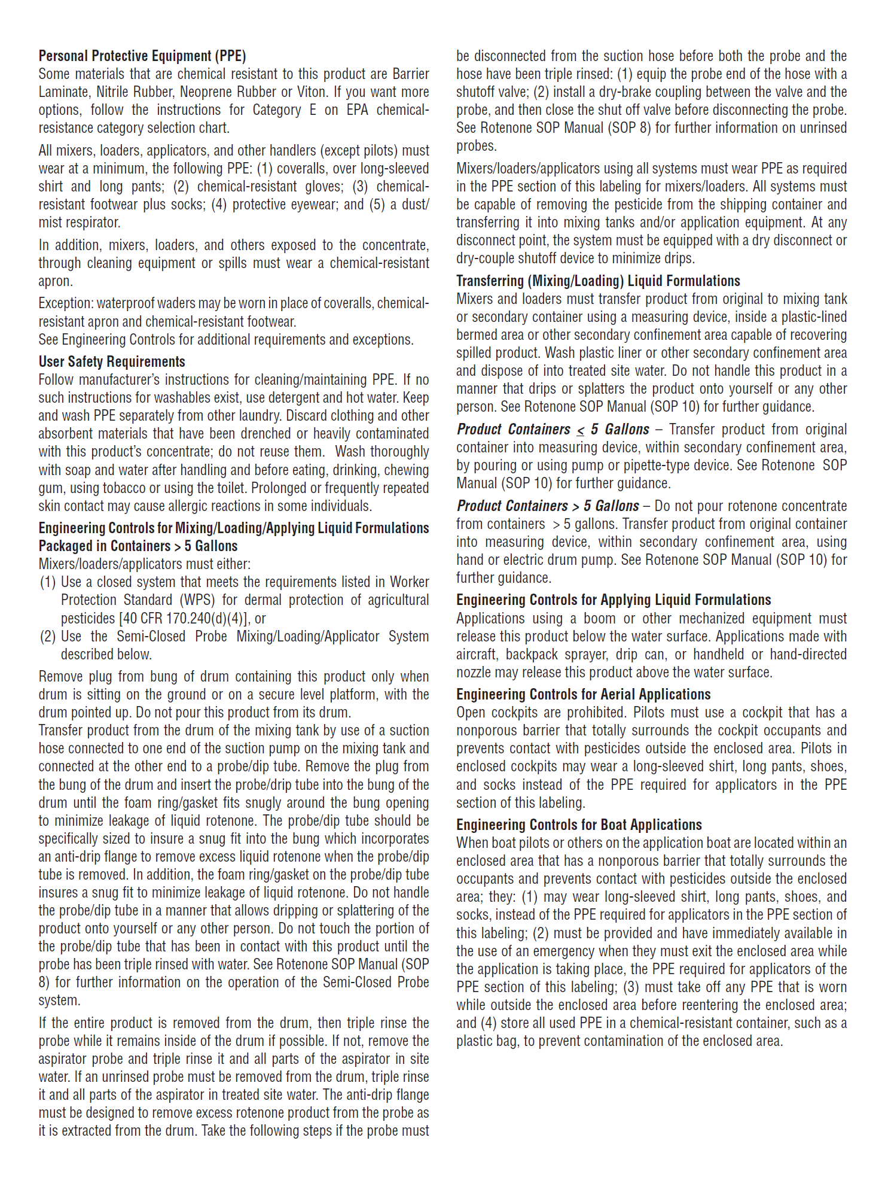

Appendix 12 page 3 of 6

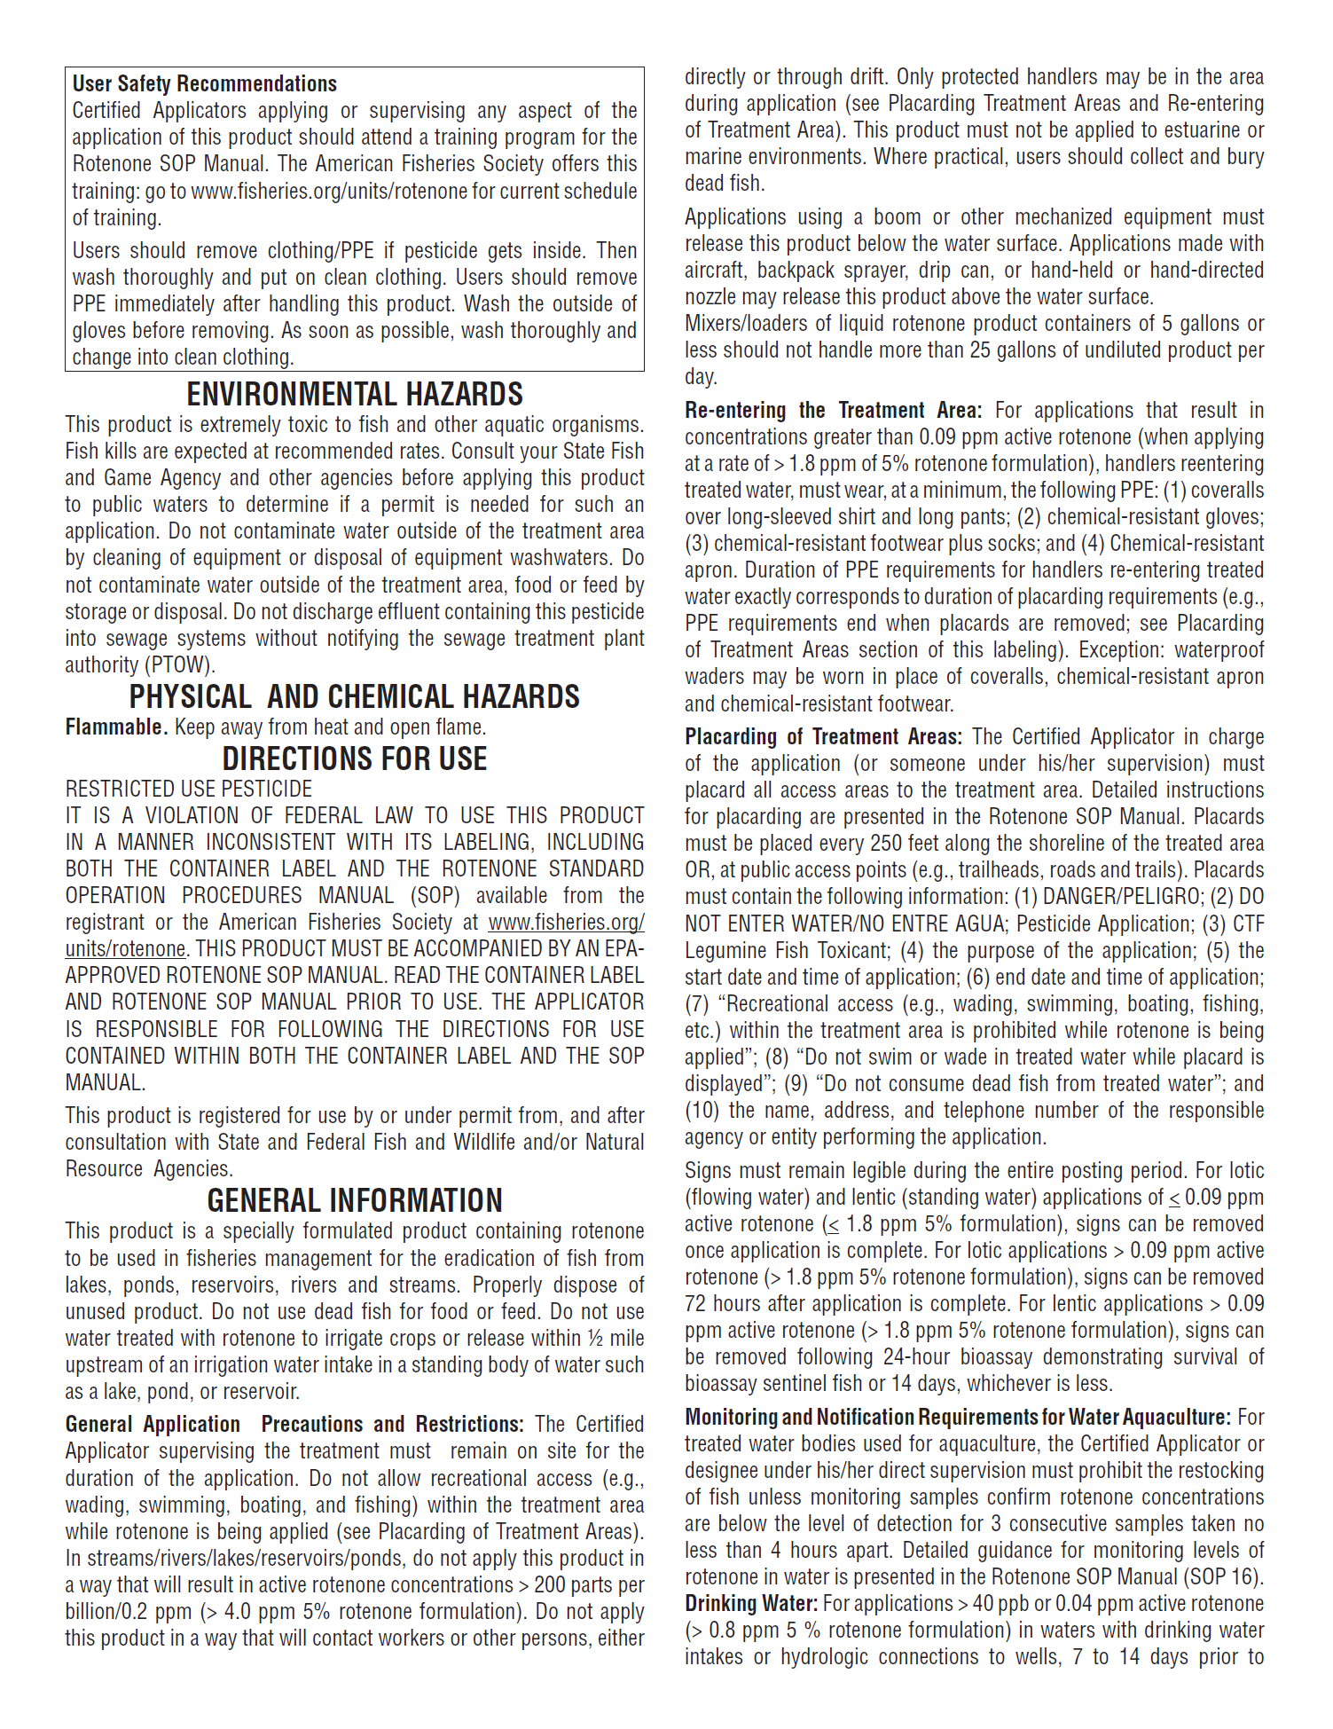

Appendix 12 page 4 of 6

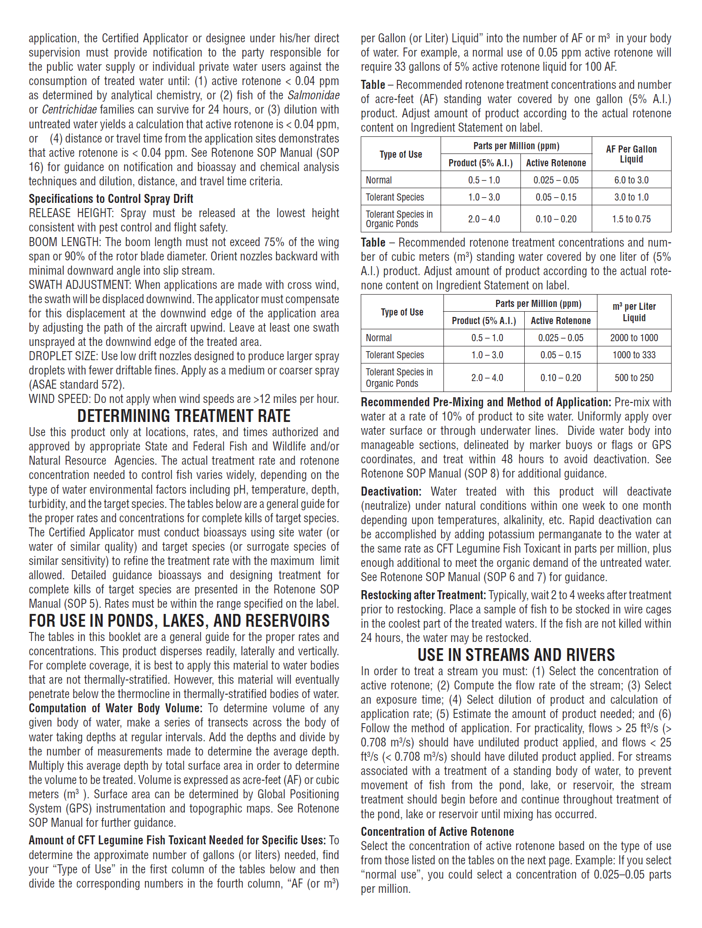

Appendix 12 page 5 of 6

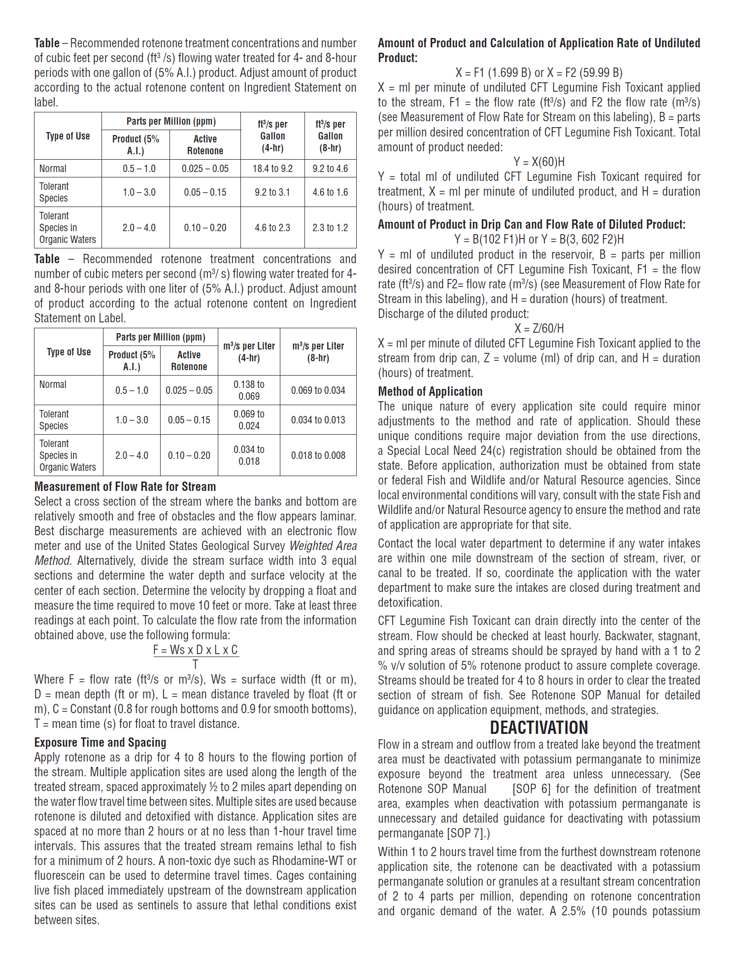

Appendix 12 page 6 of 6

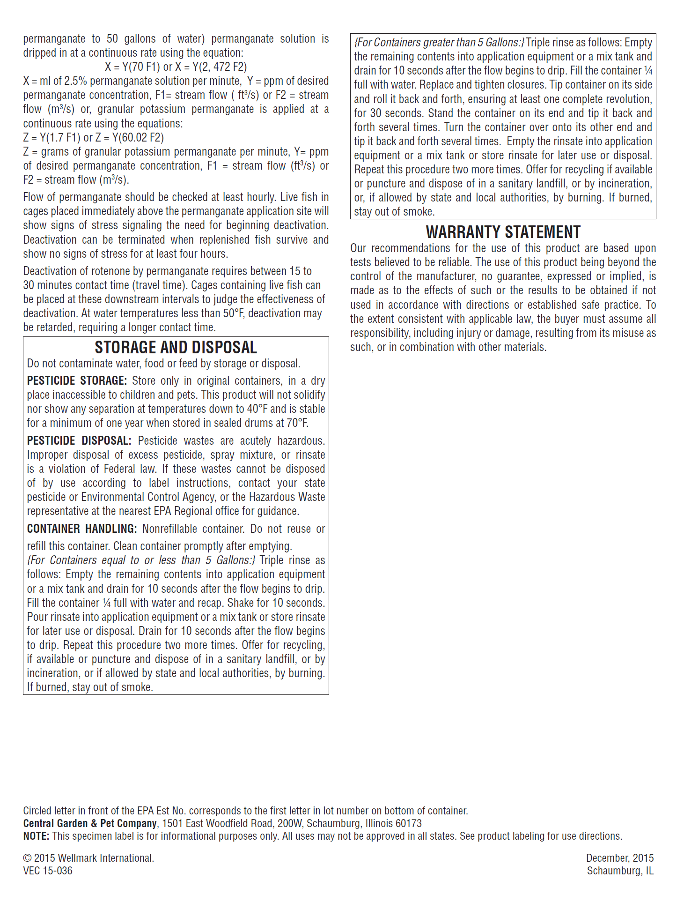

Appendix 14. Safety Plans

Page 1 of 14

**Purpose**

These safety plans are intended to identify and mitigate the potential safety hazards associated with the TRPL project. The plans are specifically designed for ADFG employees. The plans describe the safety procedures and equipment that will be utilized during the TRPL project.

This project will have two project leaders. Project leader duplicity is intentional so if one project leader becomes unavailable the other can continue to move the project forward. The project leaders have the primary authority to monitor and assess hazardous and/or unsafe situations and develop measures for assuring personnel safety. The project leaders will be available on site during the application phase of the project to oversee that project safety plans are adhered to and project objectives are met. The potential hazards associated with this project can be categorized into the following groups: (1) pesticide safety, (2) spills, (3) general safety hazards, and (4) heat stress to workers.

Safety training will ensure that all treatment team members are appropriately trained for their assigned tasks. All formal training shall be documented using ADFG’s “Safety Certification Form” (Supplement A on page 47). All training records will be maintained and archived by the project leader.

**1. Pesticide Safety**

**A. Supervision/Notification/Access Control**

Pesticide applications must be supervised by an ADFG employee who has obtained his or her Qualified Applicator Certificate in the Aquatic Category from the Alaska Department of Environmental Conservation. During the treatment phase of the project, access to TRPL waters and work sites (loading areas, equipment and supply staging areas) will be limited to appropriately trained personnel. Because nearly all of the land surrounding the treatment area is private, notifications will be given to all landowners with property adjacent to a TRPL waterbody advising them stay away from the treatment area (lakes) and to not contact or drink TRPL waters until rotenone detoxification is confirmed by ADFG. At least one week prior to treatment public notification signage will be placed at potential TRPL access locations in accordance to ADEC regulations and the Rotenone SOP Manual.

**B. Pesticide Safety Training**

All TRPL team members will receive pesticide safety training specific to the use of CFT Legumine™ and will work under the direct supervision of a Certified Applicator. Training is based on Hazard Communication Standard (29 CFR 1910.1200). All the information in the

Appendix 13 page 2 of 14

training will be provided in both written form and classroom/field instruction. Team members must sign a written record verifying their training in a Record of Pesticide Training and Training Outline (Supplement A).

The training will consist of the following topics listed below (see Supplement B for material references):

1. verbal warning of the information and warnings on the product(s) label and SDS documents
2. review of the information on the products labels and the Rotenone SOP that include what chemicals are in the products, first aid and health warnings, proper use of PPE, and directions of applying rotenone should include instruction on 1) application site, 2) dosage rate, 3) application methods and equipment, 4) dilution instructions, 5) application timing and frequency, and 6) restricted entry interval
3. Review of the products SDS that includes 1) how rotenone can affect health, 2) what to do in an emergency (first aid) listed on the MSDS, 3) information on the need to wear PPE , how to care for PPE and what PPE cannot protect from (Found on MSDS), 4) information on the meaning of safety statements and safety rules for handling pesticides (See Supplement B), and 5) rights as an employee and where to find out more information on rotenone to include job safety information, safety leaflets, SDS information, when and where the pesticide will be applied, the name of the pesticide(s) and the EPA registration number.
4. Instruction on the Application of Rotenone – review how application equipment works, application timing and calibration, and the proper use of PPE listed on the product label.

Appendix 13 page 3 of 14

**Supplement A**

**Training certification.** The following employees have received on-the-job training on those subjects listed in the attached training outline:

This training has provided me adequate opportunity to ask questions and practice procedures to determine and correct skill deficiencies. I understand that performing these procedures/practices safely is a condition of employment. I fully intend to comply with all safety and operational requirements discussed. I understand that failure to comply with these requirements may result in progressive discipline (or corrective actions) up to and including termination.

Employee Name (Print) Signature Date

________________________ ____________________________ _________

________________________ ____________________________ _________

________________________ ____________________________ _________

________________________ ____________________________ _________

________________________ ____________________________ _________

________________________ ____________________________ _________

________________________ ____________________________ _________

________________________ ____________________________ _________

________________________ ____________________________ _________

________________________ ____________________________ _________

*(use another sheet for additional trainees if needed)*

**Trainer certification.** I have conducted orientation/on-the-job training to the employees(s) listed above. I have explained related procedures, practices and policies. Employees were each given opportunity to ask questions and practice procedures taught under my supervision. Based on each student's performance, I have determined that each employee trained has adequate knowledge and skills to safely perform these procedures/practices.

________________________ ____________________________ _________

Trainer Name (Print) Signature Date

Supervisor validation. On (date) I conducted a formal observation of the above and certify that they are demonstrating adequate knowledge and skills to safely perform the procedures/practices covered in this training.

________________________ ____________________________ _________

Supervisor (Print) Signature Date

Appendix 13 page 4 of 14

**Supplement A continued**

ADFG Training Outline

Tote Road Pike Eradication Project Safety Training

**The following information was discussed with employees:**

(Enter the topics of the discussion/training here)

* Project Overview: objectives, timeline, site map, driving directions, contact lists
* Safety Procedures: PPE use, engineering controls, heat-related illness, equipment used
* Pesticide Labels, signal words, precautionary statements, first aid instructions, mixing and application instructions
* Pesticide Handling Procedures: container handling, storage, transport, disposal, mixing and application equipment, triple rinse containers, site safety
* First Aid and Decontamination: for eyes and skin and location of first aid supplies and emergency contact numbers
* Symptoms of overexposure: common symptoms of pesticide poisoning and ways poisoning can occur
* Exposure Hazards: including both acute and chronic effects
* Environmental Concerns: drift, runoff and wildlife hazards
* Laws and Regulations: applicable laws and regs, MSDS, Pesticide Info Series, label requirements
* Employee Rights: receive info on pesticides they might be exposed to, rights against discharge or discrimination due to exercise of those rights
* Location of Documents: Hazard Communication Program plans, pesticide use records, Pesticide Safety Information Service, MSDS and training records
* Review Spill and Emergency Plans, precautions specific to site and chain-of-command
* Communication protocol
* Employer responsibilities/accountability
* Employee responsibilities/accountability

**The following procedures were practiced or demonstrated:**

(Enter the practiced/demonstrated procedures here)

* PPE use
* Application equipment use (onsite instruction)

Appendix 13 page 5 of 14

**Supplement B**

**Safety Training References**



Appendix 13 page 6 of 14

**C. PPE Use**

All ADFG employees who apply CFT Legumine™ including all mixers, loaders, applicators, cleaners and other handlers (except pilots) must wear at a minimum, the following PPE: (1) coveralls, over long-sleeved shirt and long pants; (2) chemical-resistant gloves; (3) chemical-resistant footwear plus socks; (4) protective eyewear; and (5) a dust/mist respirator. In addition, mixers, loaders, and others exposed to the concentrate, through cleaning equipment or spills must wear a chemical-resistant apron. Exception: waterproof waders may be worn in place of coveralls, chemical-resistant apron and chemical-resistant footwear.

All PPE must be clean and in good repair at the start of each work day. Each employee who handles rotenone products will be issued coveralls, gloves, goggles and if needed, boots or waders. Ripped or damaged PPE must be replaced immediately. Extra PPE (equal to approximately 50% of the total number of rotenone handlers) will be available onsite. Dust/mist masks must be changed daily or when dirty.

The loading of rotenone containers will occur in a loading zone which will be delineated with orange cones. No employee will be allowed within the loading zone without appropriate PPE. Anyone working on a boat or dock will also be required to wear a life vest in addition to PPE. Team members engaged in fish cleanup and sentinel fish monitoring will be required to wear, at a minimum, waders and disposable nitrile gloves.

**D. First aid and washing supplies**

First aid kits, clean water, soap, and single-use towels for routine washing of the hands and face and emergency washing of the entire body will be available at the staging area of each lake being treated. First aid kits, eyewash solution and disposable wipes will also be available on all watercraft actively engaged in the treatment. Similarly, eyewash and disposable wipes will be available to all backpack applicators and are located in fanny pack kits that must be worn by the applicators.

**E. Pesticide Exposure Medical Care**

See Emergency Response Chart below for actions required for various types of rotenone exposure.

Appendix 13 page 7 of 14

**Exposure Response Chart**



Copies of all rotenone product labels and safety data sheets (SDS) documentation will be available to all team members and extras copies available at the onsite staging location to be provided to any medical professionals as needed

Team members who are exposed to CFT Legumine should follow the directions found in the Exposure Response Chart listed above. All pesticide exposure emergencies should be reported as soon as possible to the project leader. Each team member will be issued a miniaturized Exposure Response Chart to carry with them in the field for reference. All pesticide applicators working beyond the line of sight of the project leader must either have a cell phone or walkie-talkie in their possession or in the possession of a team member working alongside them.

**F. Pesticide Storage and transport**

Long term storage of pesticide will occur in an enclosed locked area with appropriate ADEC warning signage posted on the entry door. The storage area must be temperature controlled to stay above 40F. The pesticide containers must be kept inside a bermed spill containment system. In the storage area there must be a spill control kit (including PPE), emergency contact numbers and product SDS and Specimen Label documents. Long term storage will be at the ADFG Crooked Creek Maintenance and temporary warm weather storage may be in the fenced in storage compound at eh Soldotna ADF&G office.

Onsite storage of rotenone, regardless of amount, requires storage either on a tarp that slopes towards the treatment waterbody so runoff must enter the treatment area or inside a spill containment system. A spill kit must be present whenever more than five gallons is present.

Appendix 13 page 8 of 14

Federal codes regulating transport of hazardous materials exempts state agencies from many requirements regarding hazardous materials training, license endorsements and placarding as described below:

In accordance with federal Hazardous Materials Regulations (HMR) § 49 CFR 171.1 (d)(5), which states:

(d) Functions not subject to the requirements of federal Hazardous Material Regulations (HMR).

…(5) Transportation of a hazardous material in a motor vehicle, aircraft, or vessel operated by a federal, state or local government employee solely for noncommercial Federal, state, or local government purposes.

The Alaska Department of Fish and Game is exempt from HMR(§ 49 CFR 171 through 180) as it applies to Packaging, Pretransportation, and Transportation functions of hazardous materials.

For questions contact the Alaska Department of Transportation and Public Facilities (907-365-1210).

However, the following travel precautions will be implemented for this project:

All vehicles transporting rotenone will:

1. tether pesticide containers securely to the vehicle or trailer to prevent movement
2. carry a document stating the state operated vehicle is in compliance with (HMR) § 49 CFR 171.1 (d)(5) (see supplement C)
3. have spill kit present (fifty gallon plastic container, garbage bags, shovels, absorbent pads, activated charcoal (five gallons), eye wash, first aid kit, flagging, and PPE for at least two people
4. have the product SDS available
5. have emergency contact phone numbers available including an ADEC Spill Prevention and Response contact and an emergency contact number for someone in the Department serving as the project leader
6. all vehicles transporting rotenone will slow down at least five miles an hour below the posted speed limit while crossing any bridge or culvert over water to reduce the chance of an accident occurring that could lead to an unintentional discharge into water.

Appendix 13 page 9 of 14

**Supplement C**

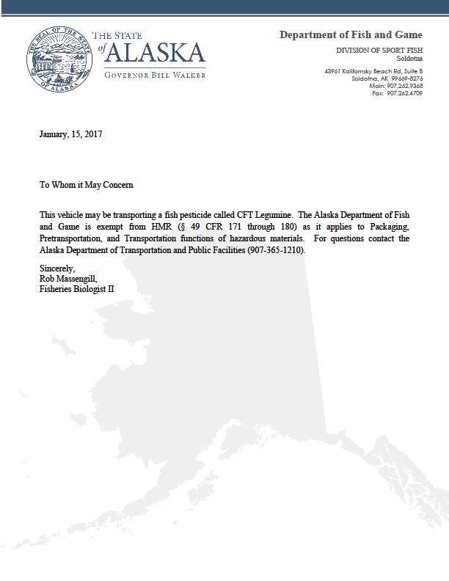

Appendix 13 page 10 of 14

**2. Spills**

**Spill Response**

If a rotenone spill occurs, the sequence in a workers response should be to Control, Contain and Clean up the spill (when practical). Workers should not expose themselves unnecessarily to chemicals from a spill and should wear full PPE before attempting to address a spill. If a spill is large and dangerous, call for help first. The project supervisor must be notified as soon as possible.

**Control:** When possible, workers should take immediate steps to control the release of the product being spilled such as stopping a leak by uprighting a turned over container, putting a leaking container into a larger container (i.e. garbage can, spill containment area or boat), or by pumping liquid from a leaking container into another container.

**Contain:** Contain the spill when practical; sand/dirt can be used to berm around a spill area and absorbent pads, sand or charcoal can be placed on the spill to help absorb it. Absorbent materials will be located in all application boats and at the staging area.

**Clean up:** Once a spill is contained, clean up the spill by sweeping or shoveling the contaminated material into a container lined with a heavy plastic bag. Bleach, chlorine or charcoal can be used to neutralize the spilled area.

To reduce the possibility of an accidental spill during transport, all product containers will be tethered securely into the transporting vehicle or trailer. To move the product containers to vehicles or boats, loading ramps or a forklift will be used to move the containers > five gallons. If a spill occurs, a spill response kit must be with the transporting vehicle or the loading area. The spill response kit will contain shovels to remove contaminated soil, a large plastic container to hold contaminated material/soil (50 gallon volume), absorbent pads, activated charcoal (10 gallons), dry sand (10 gallons), plastic garbage bags, personnel protective equipment for at least two people, a 100-foot roll of 3-6 foot impervious barrier, pesticide transfer hand pump and a gallon of bleach, caution flagging, spill emergency numbers, eyewash, disposable wipes and some form of warning sign or signal. (orange cones, warning signage etc.).

Any recovered contaminated soil will be treated as if it where the pure rotenone pesticide, and PPE will be worn to clean up the spill. If there is a spill outside of the treatment area and there is a chance it could enter surface waters out of the project area, then the disposal of the contaminated soil to an approved landfill may be required. For any spill onto soil near a treatment area, the contaminated soil will be removed and treated as if it were the pure pesticide and applied to the treatment area. Activated charcoal will be mixed into the soil where it was excavated at a rate of 100 to 1 (charcoal to active ingredient) as suggested online at [www.buyactivatedcharcoal.com](http://www.buyactivatedcharcoal.com) .

Washing of equipment contaminated from a spill or equipment leaks can be accomplished by washing first with water from the treatment area then with a solution of bleach (1:10 ratio bleach to water) followed by washing with a strong soap and water solution.

Appendix 13 page 11 of 14

Accidental pesticide spills of any size that result in the pesticide not entering the treatment area will be immediately reported by the project supervisor and to:

1. the ADEC hazardous spill number (1-907-269-3063),
2. the local ADEC Office (1-907-262-5210),
3. Kenai Peninsula Borough Emergency Services (1-907-262-4792),
4. Kenai Borough Emergency Management Office (1-907-262-4910).

In addition CHEMTREC provides access to emergency response information and technical assistance from chemical industry experts and can be contacted for emergency assistance at 1-800-424-9300. Local and State Law enforcement should be notified if a spill occurs on a public highway. For rotenone product information, the National Pesticide Information Center can also be contacted at 1-800-858-7378. These emergency phone numbers will be provided to all project personnel and should be with them at all times when working on the project.

**3. Heat Stress**

Heat stress is a potential hazard to rotenone handlers due to the requirement to wear personal protective equipment. All team members will be informed of the symptoms and hazards related to heat stress. Further, all pesticide handlers will be encouraged to drink liquids frequently (~every 20 minutes of work) take appropriate work breaks and participate in heat stress monitoring.

Team members that suspect that they are suffering from the effects of heat stress will be instructed to immediately stop working, rehydrate and remove excessive clothing. The project supervisor shall be immediately notified, and if necessary, the affected person be given medical care.

**4. Pesticide Storage/Staging Areas and Transport**

Storage of large quantities of rotenone product(>30 gallons liquid product or 110 lbs. of powdered product) when the storage arrangement is not capable of draining spilled product into a waterbody destined for treatment, the product will be stored within a bermed area lined with a plastic fabric capable of containing all the rotenone product. A spill response kits and PPE will be onsite at all storage locations including emergency contact numbers.

When possible, onsite storage of rotenone delivered to individual lakes/streams will be stored in such a way that an accidental spill would drain towards the waterbody destined to be treated.

Federal codes regulating transport of hazardous materials exempts state agencies from many requirements regarding hazardous materials training, license endorsements and placarding, however as explained below:

In accordance with § 49 CFR 171.1 (d)(5), which states:

(d) Functions not subject to the requirements of federal Hazardous Material Regulations (HMR).

Appendix 13 page 12 of 14

…(5) Transportation of a hazardous material in a motor vehicle, aircraft, or vessel operated by a federal, state or local government employee solely for noncommercial Federal, state, or local government purposes.

The Alaska Department of Fish and Game is exempt from HMR(§ 49 CFR 171 through 180) as it applies to Packaging, Pretransportation, and Transportation functions of hazardous materials.

Please contact the Alaska Department of Transportation and Public Facilities (907-365-1210) if there are any concerns regarding this exception.

However, the following travel precautions will be implemented for this project:

All vehicles transporting rotenone will:

1. have pesticide containers tethered securely to prevent movement
2. carry a document (page two) stating their compliance with federal Hazardous Materials Regulations
3. have spill response equipment (fifty gallon plastic container, garbage bags, shovels, absorbent pads, activated charcoal (five gallons), eye wash, first aid kit, flagging, and PPE for at least two people
4. have the product MSDS available
5. have emergency contact phone numbers available including an ADEC Spill Prevention and Response contact and an emergency contact number for someone in the Department serving as the project leader
6. all vehicles transporting rotenone will slow down at least five miles an hour below the posted speed limit while crossing any bridge or culvert over water to reduce the chance of an accident occurring.

Appendix 13 page 13 of 14

**4. Incident/Crisis Command**

A crisis typically results from adverse public reaction to, or excessive media interest in, an unplanned event during or following a rotenone treatment (Finlayson 2000). All incidents such as such as spills, accidents or any potential crisis should be immediately reported by the worker observing it to project leader and emergency services (911) if necessary. The project leader will assess the situation and respond with assistance (if prudent) and/or recruit emergency services or other support. The project supervisor will decide if additional actions should be taken including notifying the Regional Research Coordinator or emergency services.

In the event of a crisis related to this project, an Incident Command System will be implemented. The incident plan consists of the following:

1. Who the worker should report to (see Incident Organizational Chart).
2. Define the problem, identify issues, selection of a crisis team, gather facts, identify a spokesperson (responsibility of Project Leader and Research Supervisor)
3. Centralize control of information (responsibility of Project Leader and Research Supervisor)
4. Communicate and negotiate at the highest level of authority (dictated by Regional Supervisor or higher)
5. Contain the problem quickly

Appendix 13 page 14 of 14

**Incident Organizational Chart**

Appendix 15. ADEC signage requirements for treatment site.

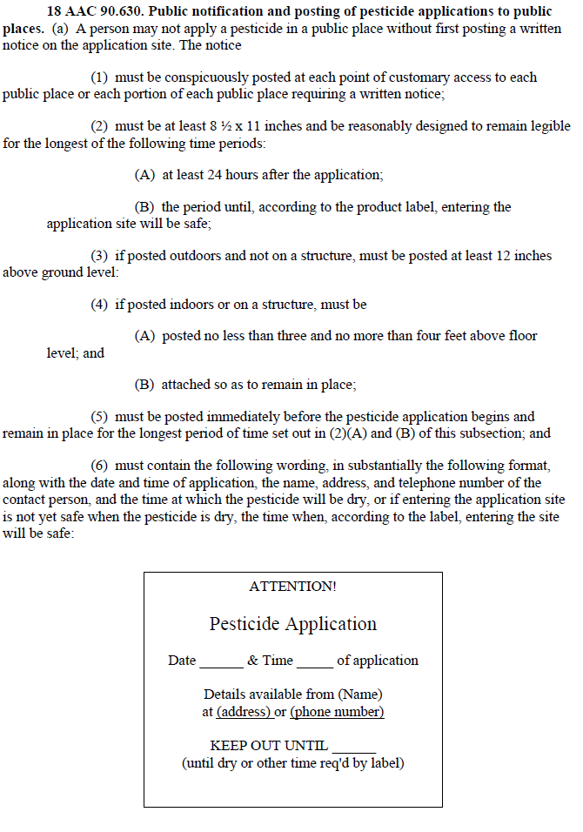

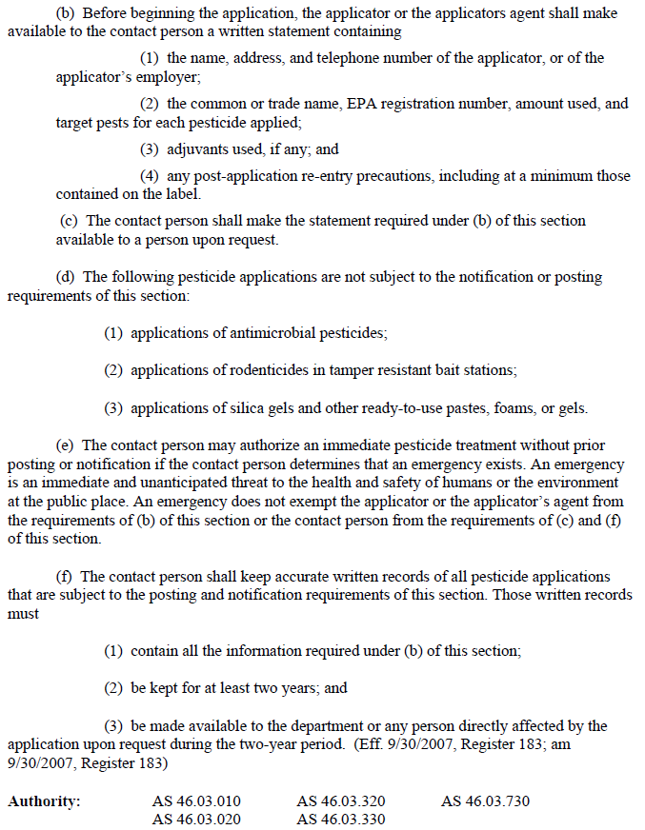

Appendix 16. ADEC pesticide recordkeeping requirements



Appendix 17. CFT Legumine™ Safety Data Sheet

Page 1 of 10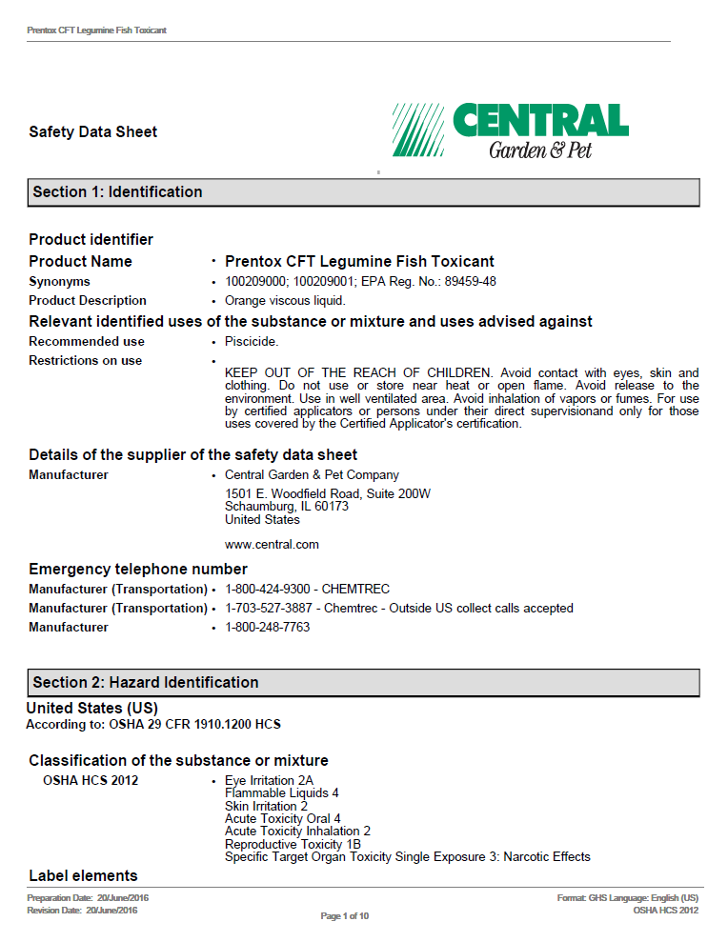

Appendix 19 page 2 of 10

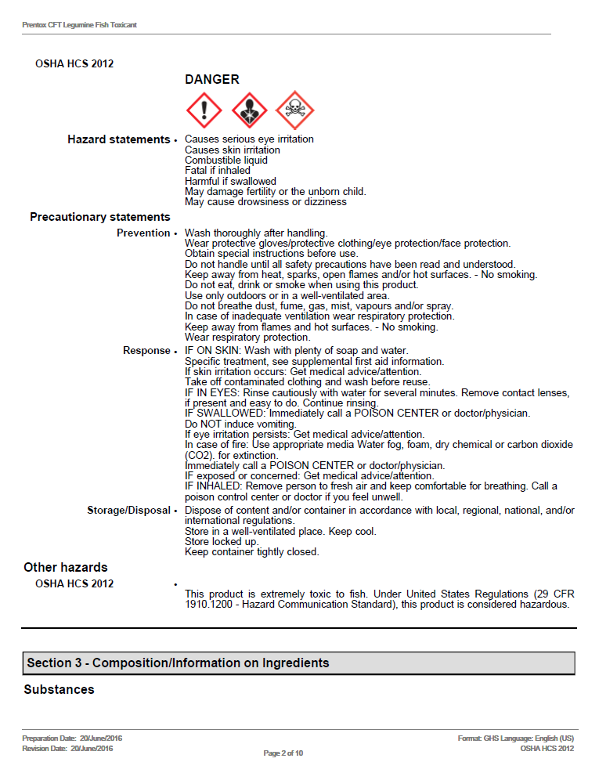

Appendix 19 page 3 of 10

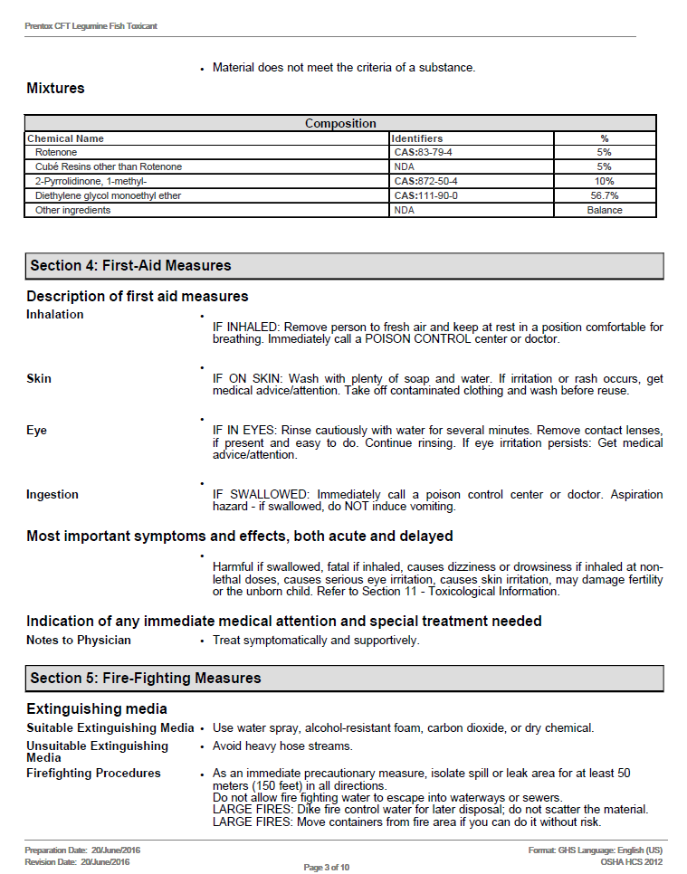

Appendix 19 page 4 of 10

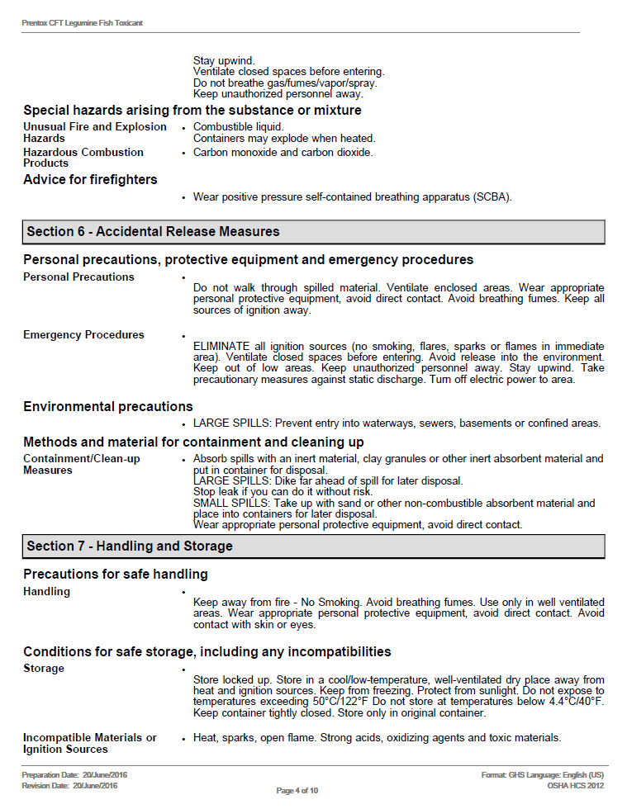

Appendix 19 page 5 of 10

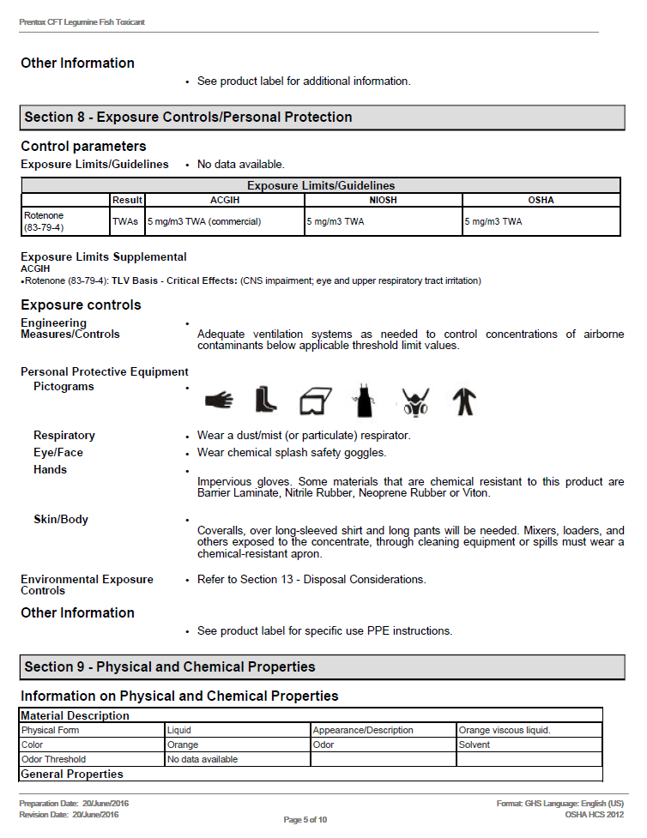

Appendix 19 page 6 of 10

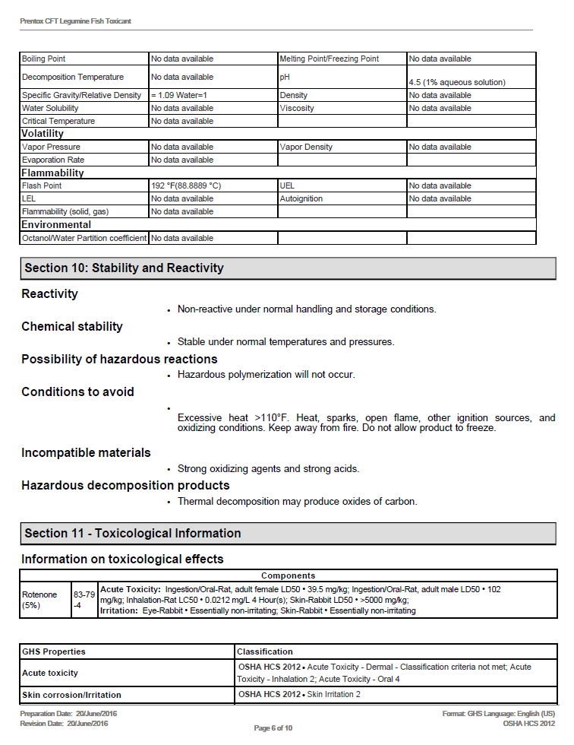

Appendix 19 page 7 of 10

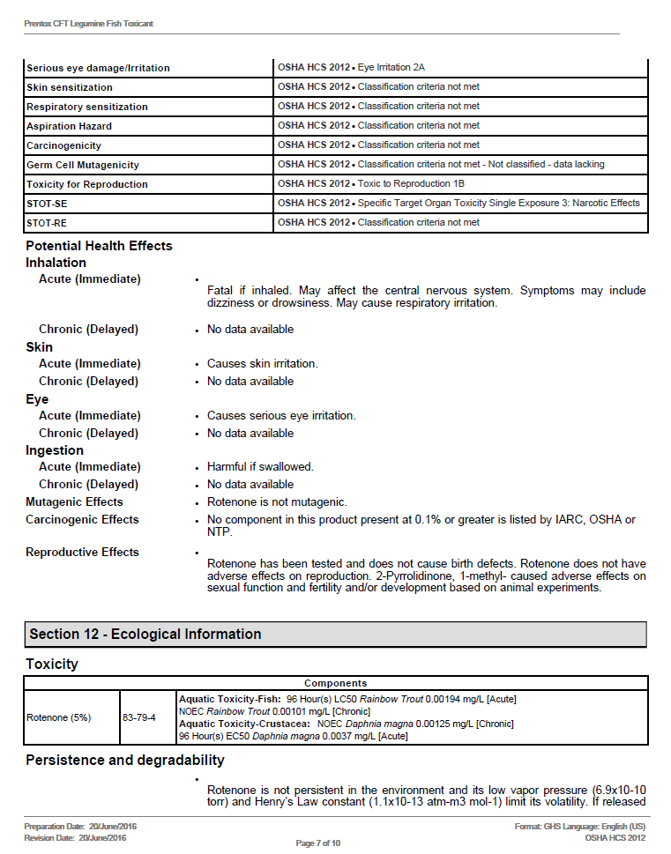

Appendix 19 page 8 of 10

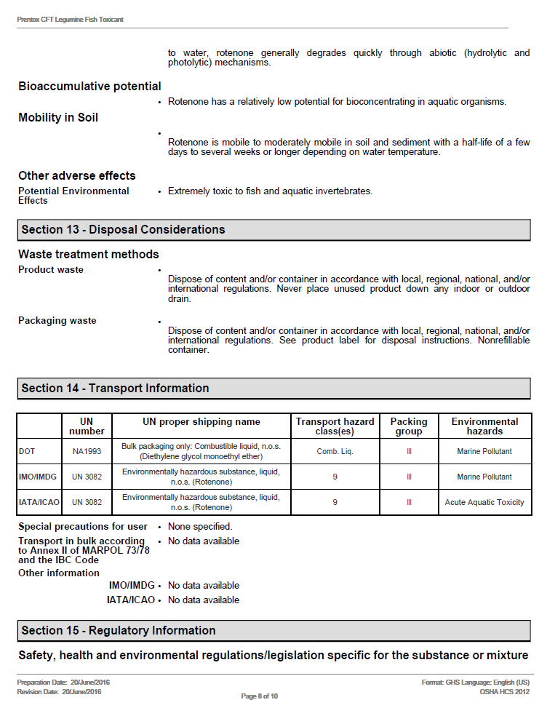

Appendix 19 page 9 of 10

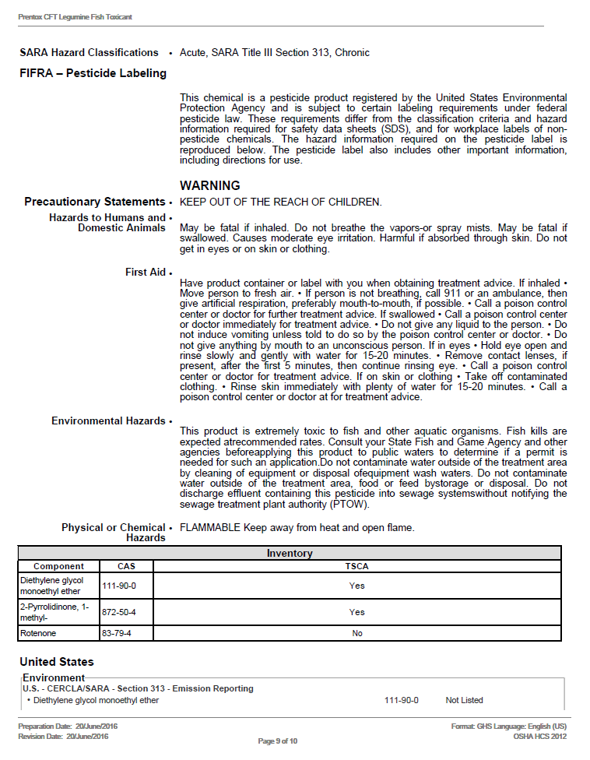

Appendix 19 page 10 of 10

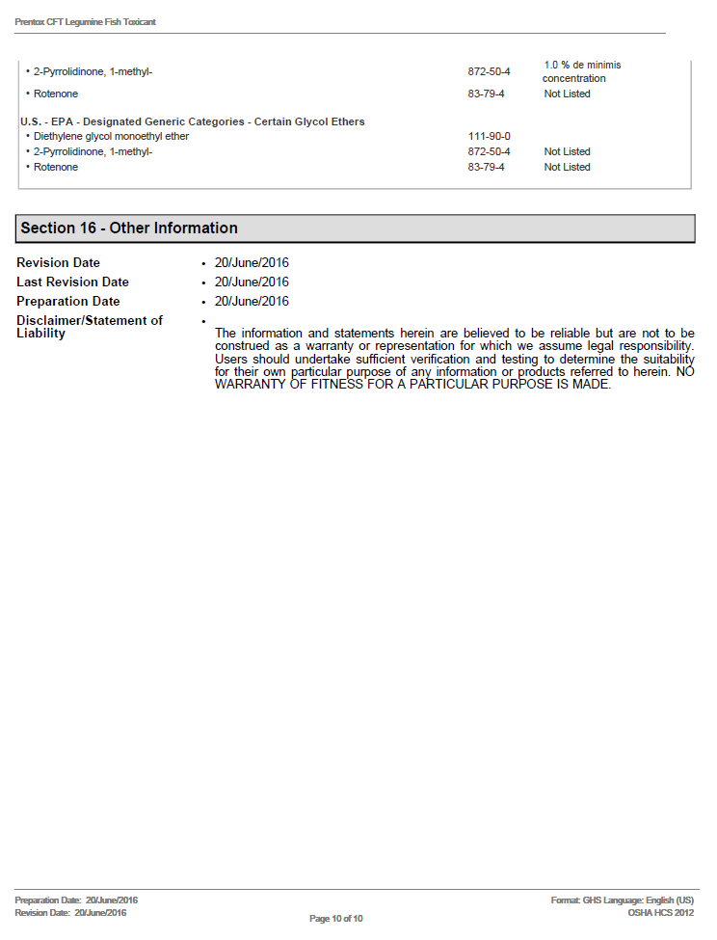

1. Probabilities will be lower than shown in table 3 in lakes where multiple samples are collected.